Brightness or lightness illusion: a catalogue (version 2012)
by Akiyoshi Kitaoka, Ritsumeikan University, December 8, 2008 (originally for “Professor Mark McCourt’s talk in Ritsumeikan”)
  Brightness contrast  The left gray square appears to be brighter (lighter) than the right one, though they are the same luminance. This effect is frequently called the “simultaneous brightness contrast”.  <Brücke, 1865> | 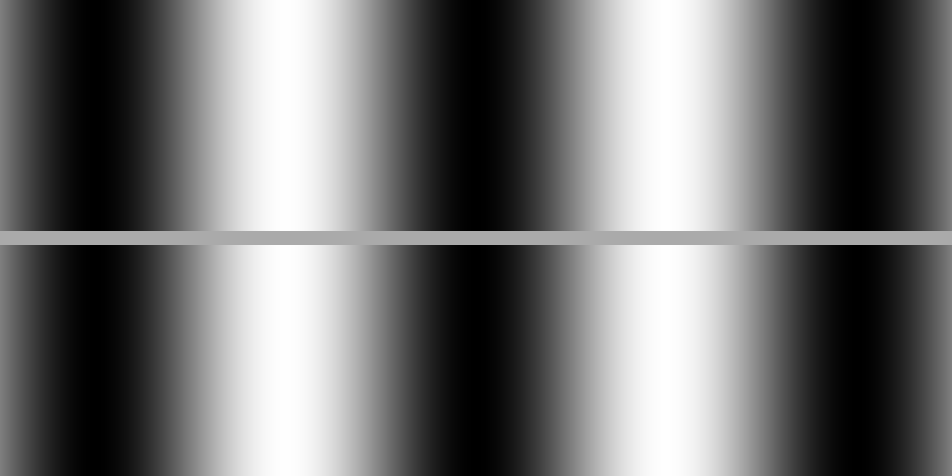  Grating induction  The homogeneous gray occluder appears to show an illusory brightness grating counterphase with the luminance grating of the background.  <McCourt, 1982> | 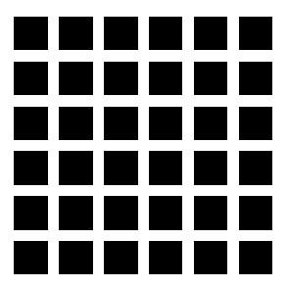  Hermann grid illusion  Illusory dark spots are observed at the crosses.  <Hermann, 1870> | 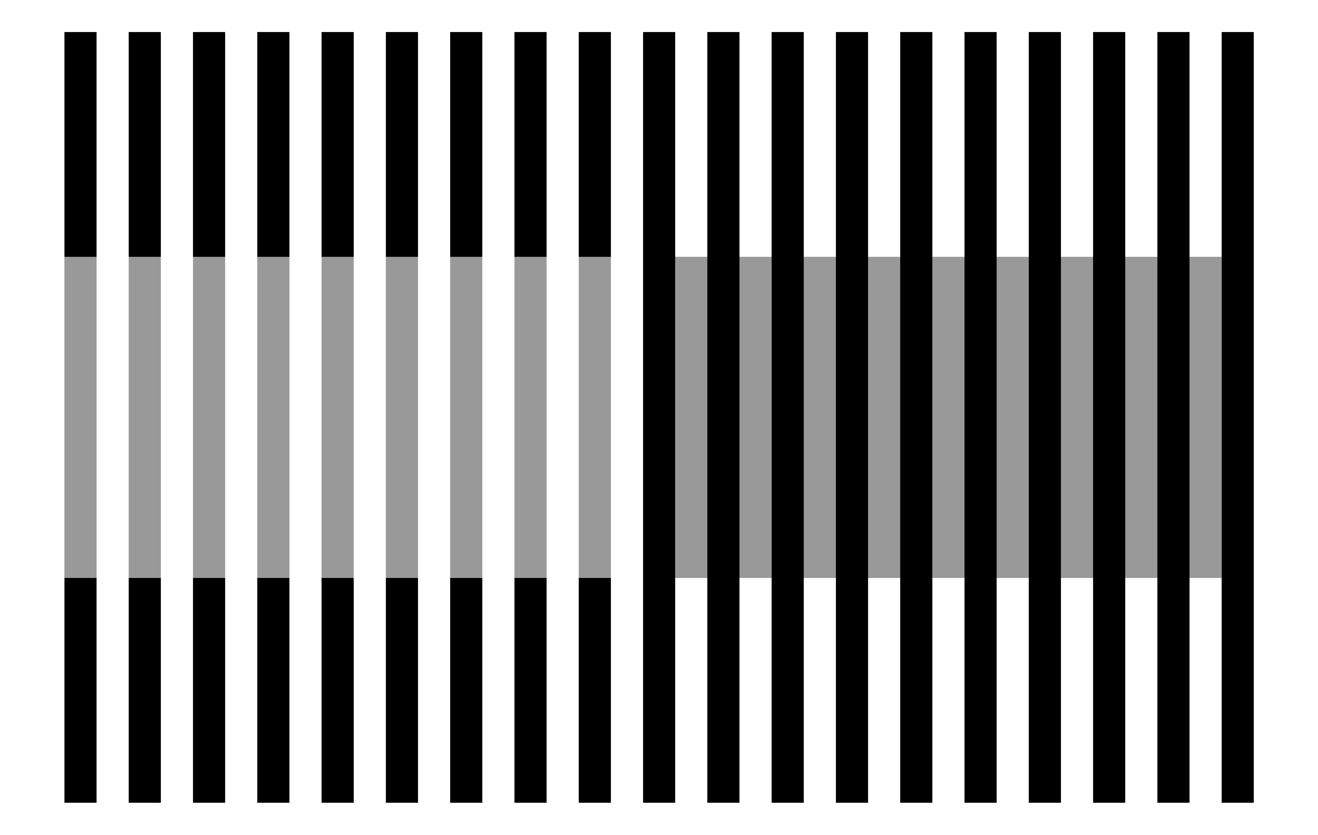  White’s effect  The left gray grating appears to be much brighter than the right one, though they are of the same luminance.  <White, 1979> | 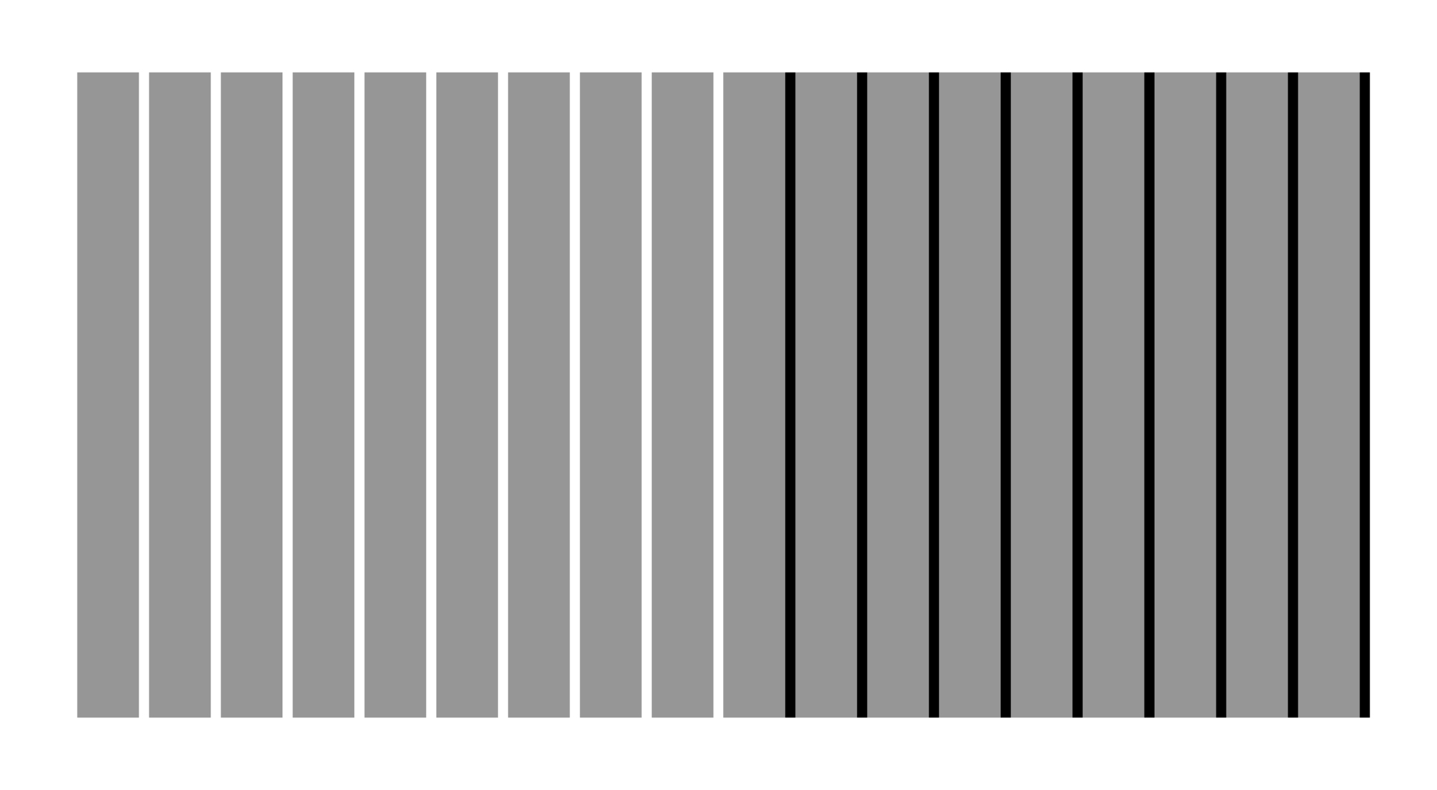  Brightness assimilation  The left half of the rectangle appears to be brighter than the right one, though they are the same luminance gray.  <von Bezold, 1874>
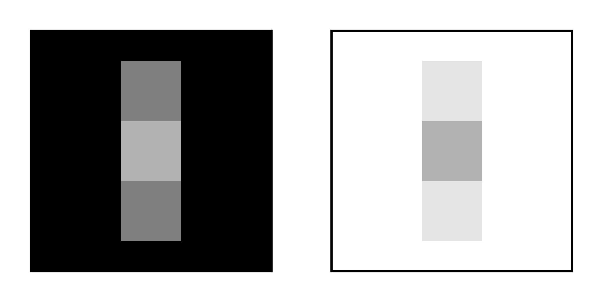  T-junction-enhanced brightness contrast  The left central square appears to be much brighter (lighter) than the right one, though they are of the same luminance.  <(Kitaoka, 2005)?> |   Articulation-enhanced brightness contrast  The left gray square appears to be much brighter (lighter) than the right one, though they are of the same luminance.  <Gilchrist et al., 1999> | 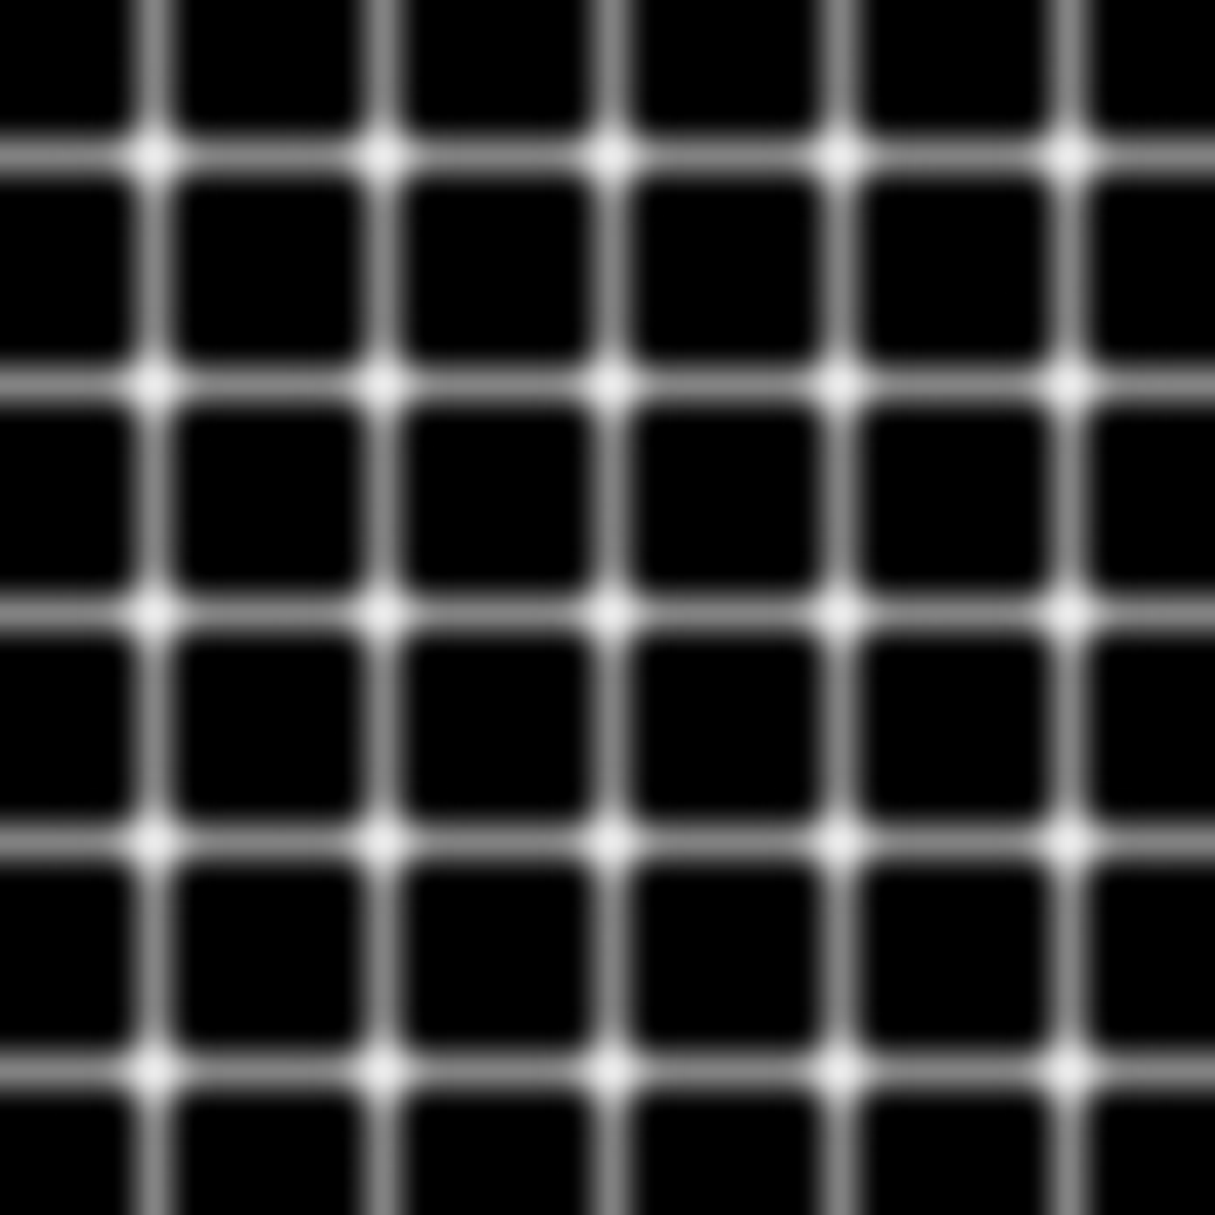  Bergen grid illusion  Illusory black spots appear to scintillate at the crosses.  <Bergen, 1985> | 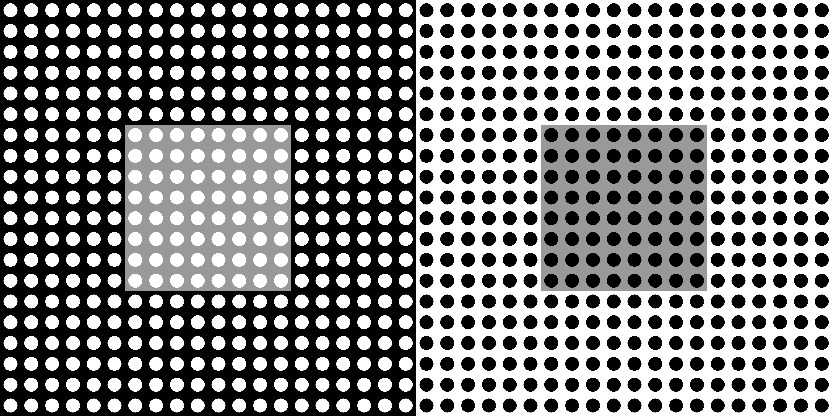  Dotted lightness illusion  The left gray square appears to be brighter than the right one, though they are of the same luminance.  <White, 1982, personal communication> | 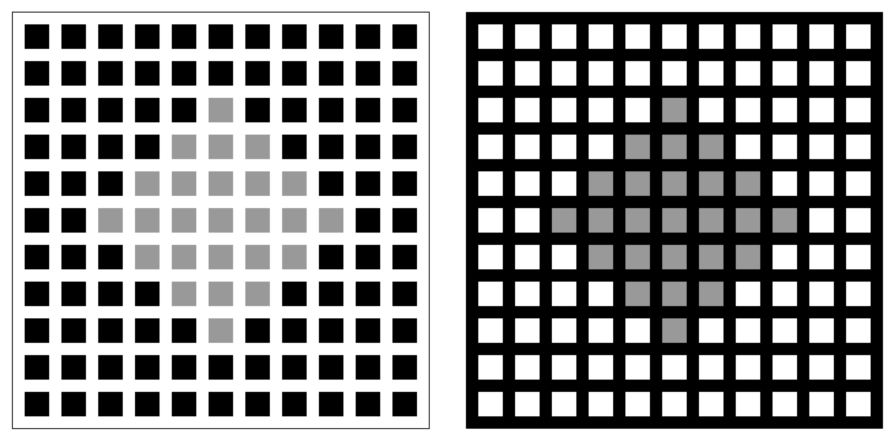  Dungeon illusion  The left gray diamond appears to be brighter than the right one, though they are of the same luminance.  <Bressan, 2001>
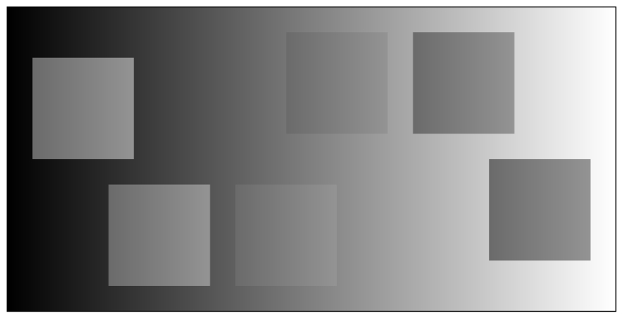  Luminance-gradient-  dependent brightness contrast  There appear six squares of different brightness, though they are of the same luminance gradient.  <Kitaoka, 2005> |   Koffka ring  If a homogeneously gray ring placed in front of a dark and bright background is split into each field, the left half surrounded by the darker part appears to be brighter than the right half.  <Koffka, 1935> |   Adelson’s ring  If the split halves are connected like this image showing transparency, the effect is enhanced.  <Adelson, 2000> | 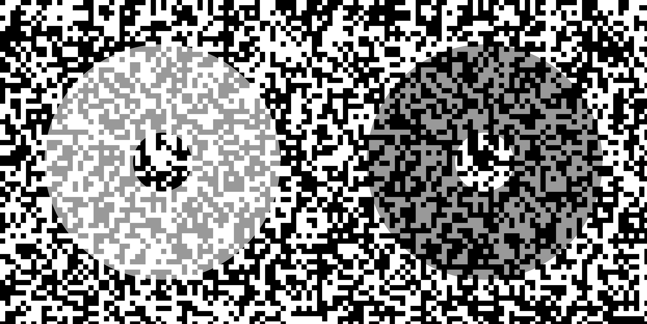  Stuart’s Rings  The left gray ring appears to be brighter than the right one, though they are of the same luminance.  <Anstis, 2005> | 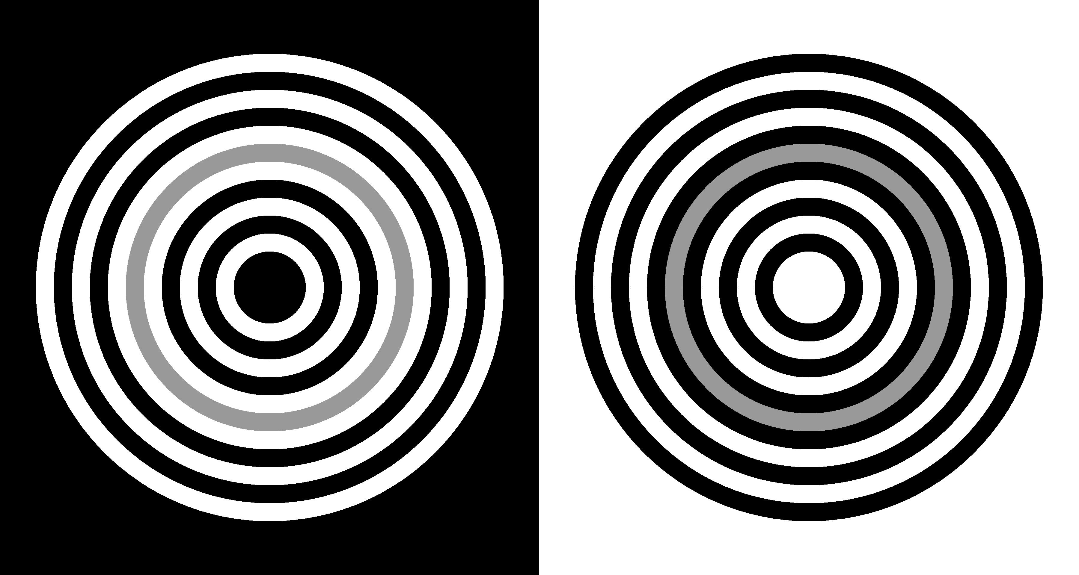  Hong-Shevell’s rings  The left gray ring appears to be brighter than the right one, though they are of the same luminance.  < Hong and Shevell, 2004>
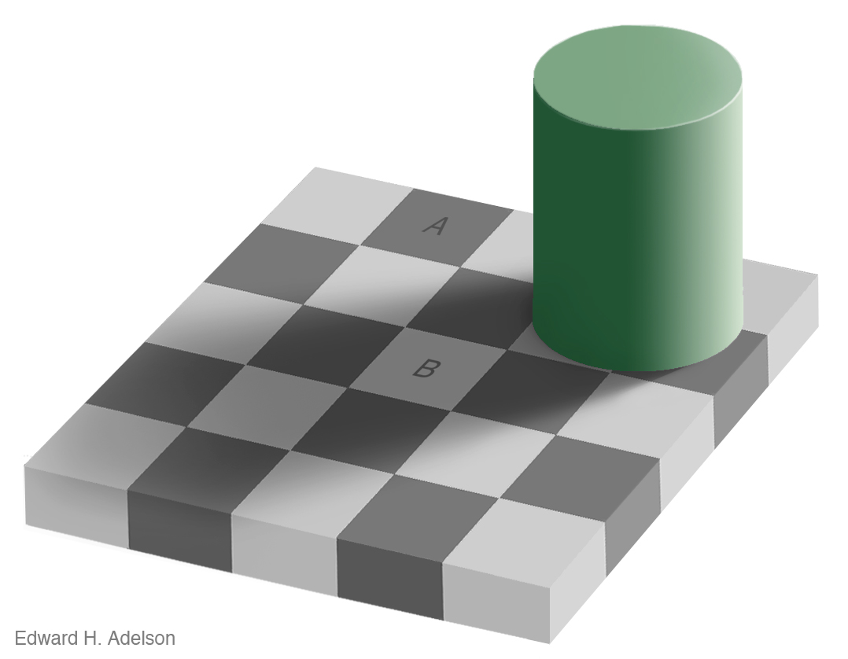  Checker-shadow illusion  ©Edward H. Adelson 1995  Although A appears to be much darker than B, the luminance of A is the same as that of B.  <Adelson, 1995> | 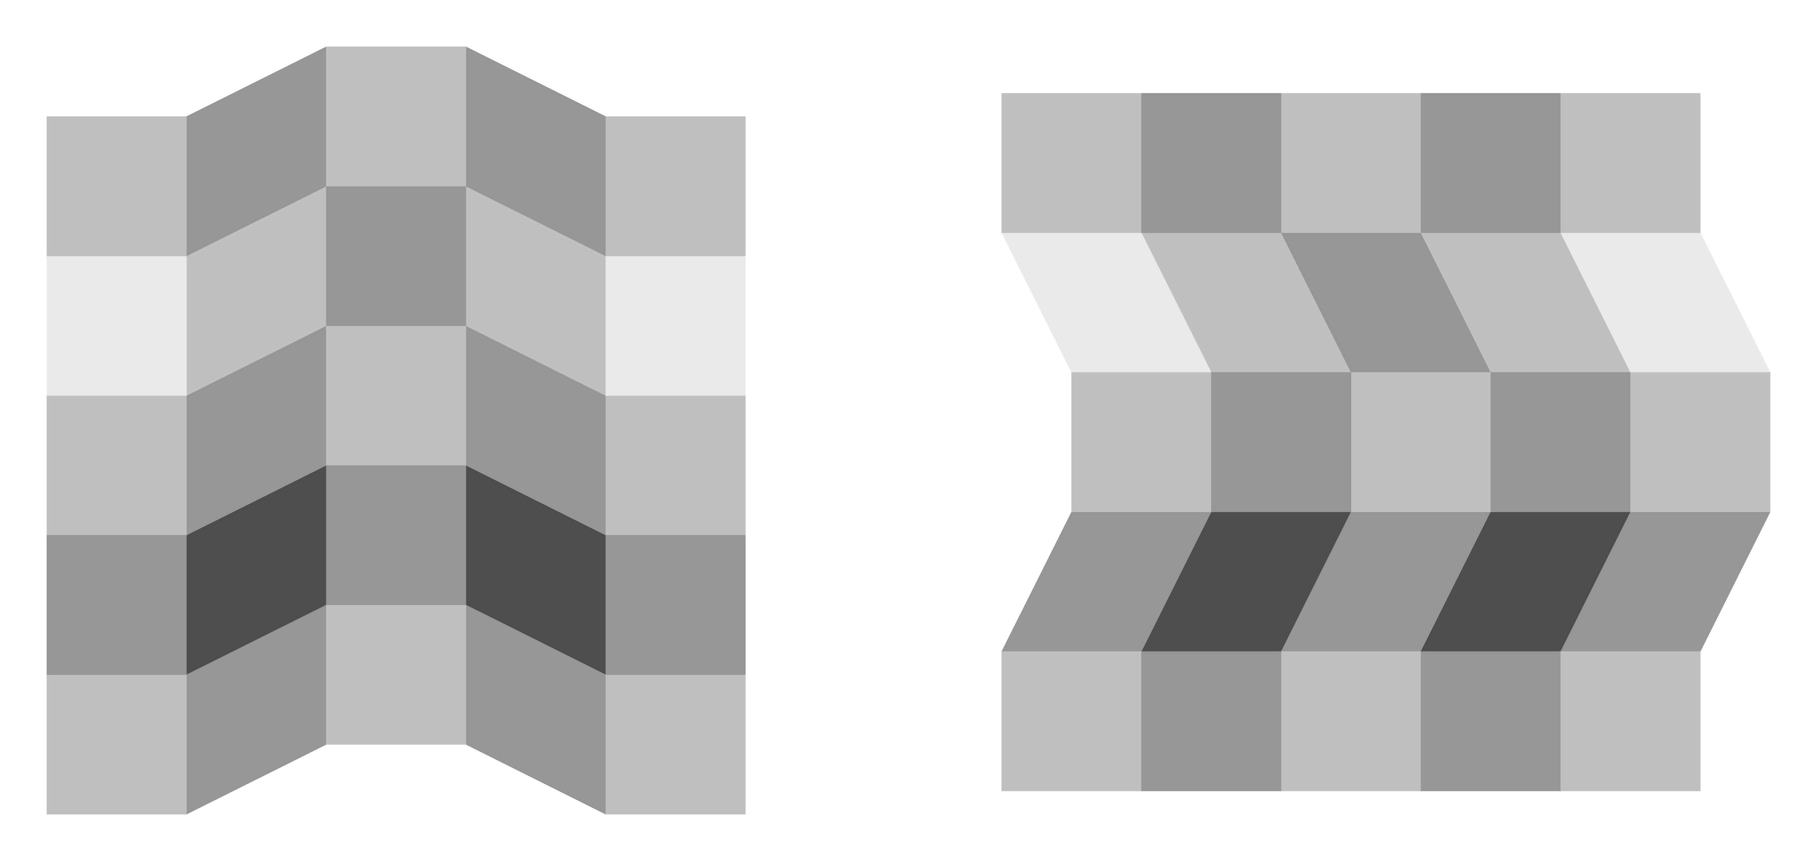  Corrugated Mondrian  For each image, the second and fourth parts in the central column are of the same luminance. They appear as it is in the left image, while in the right one the upper part appears to be darker than the lower one.  <Adelson, 1993> | 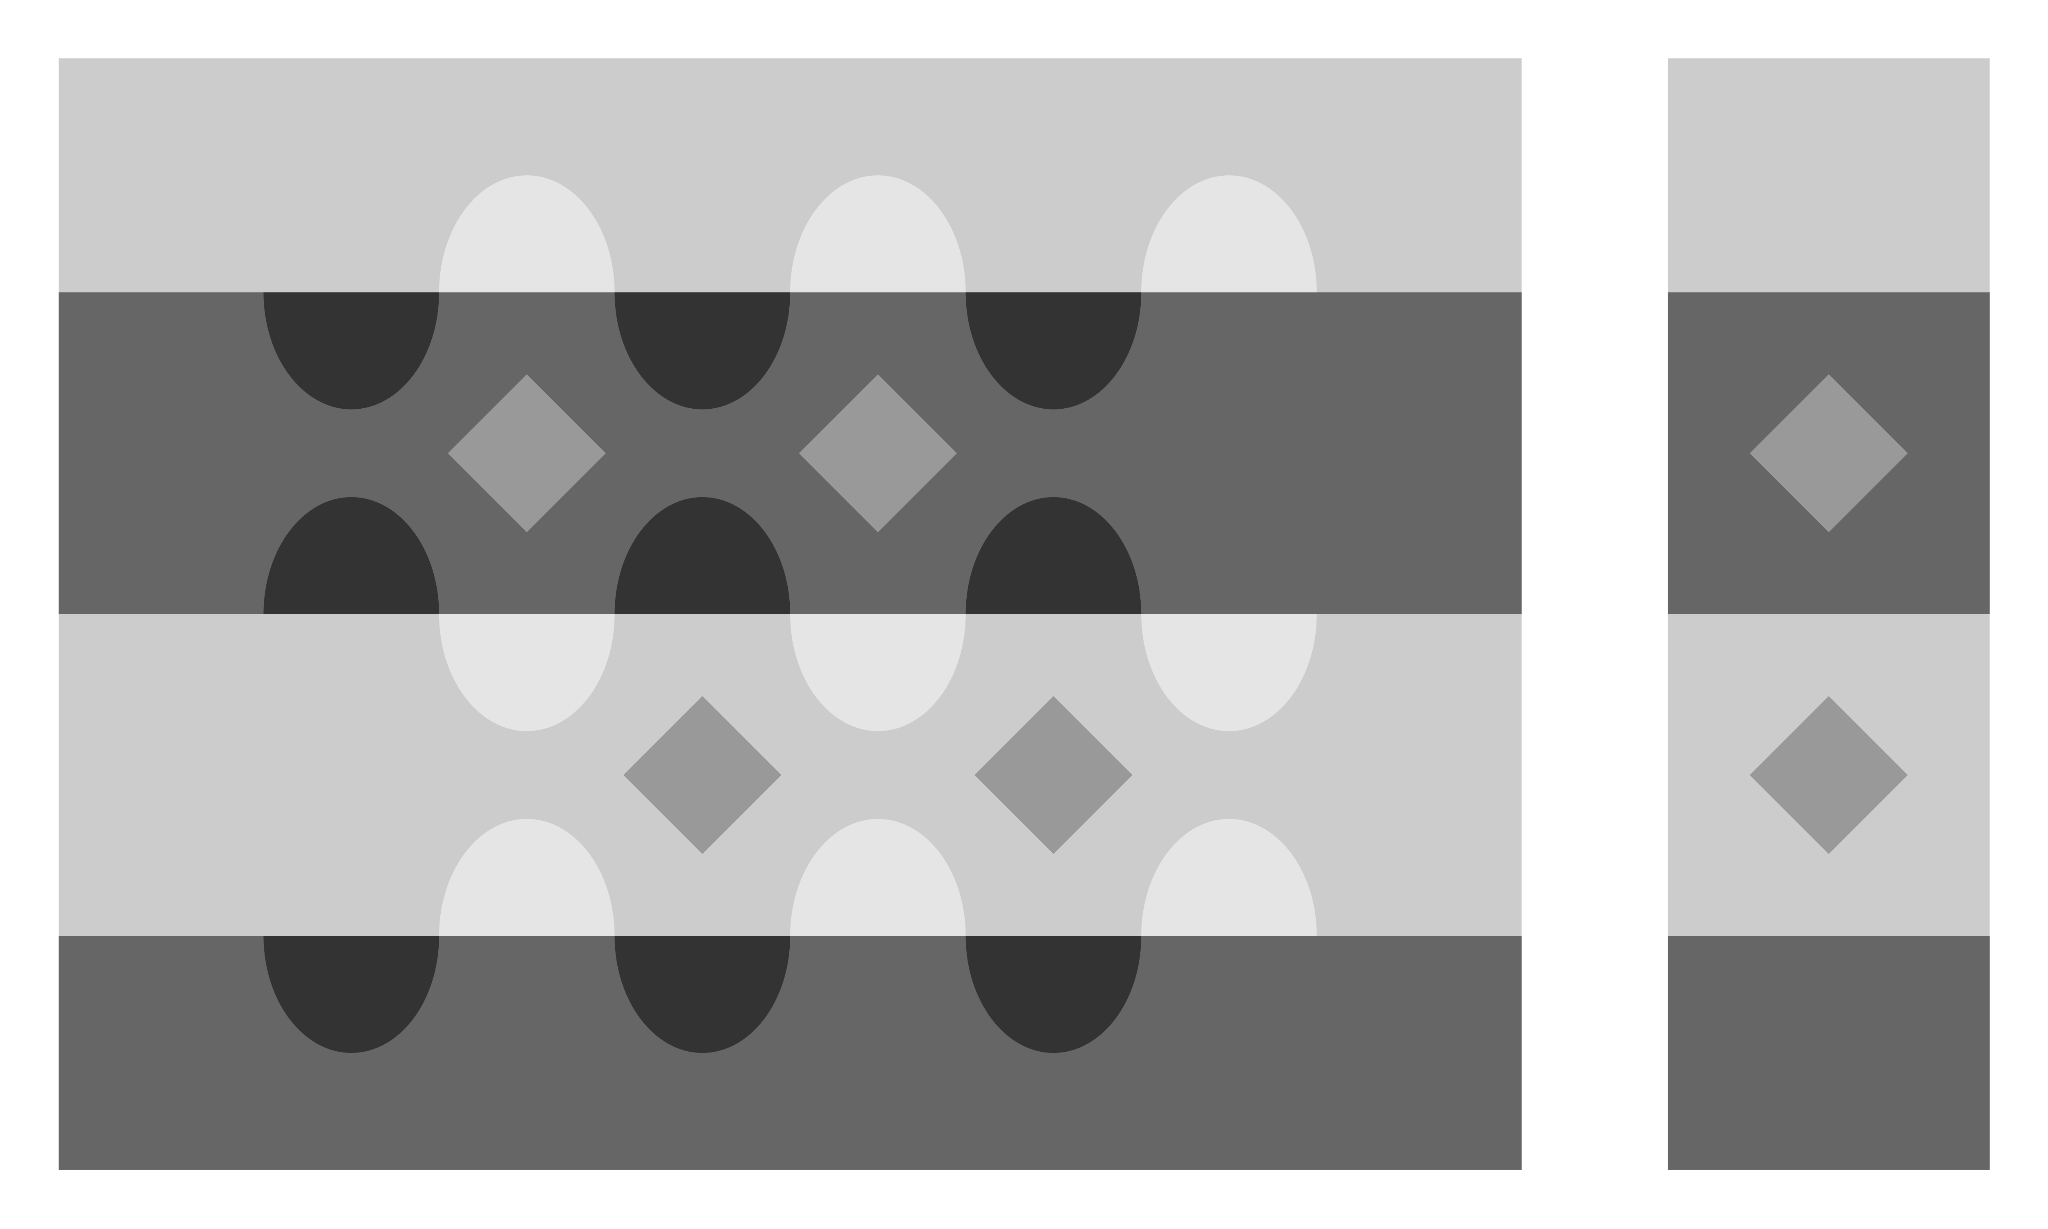  Snake illusion  In the larger block, the upper two diamonds appear to be much brighter than the lower ones, though they are the same luminance. The right block shows brightness contrast (not so strong).  < Adelson, 2000> | 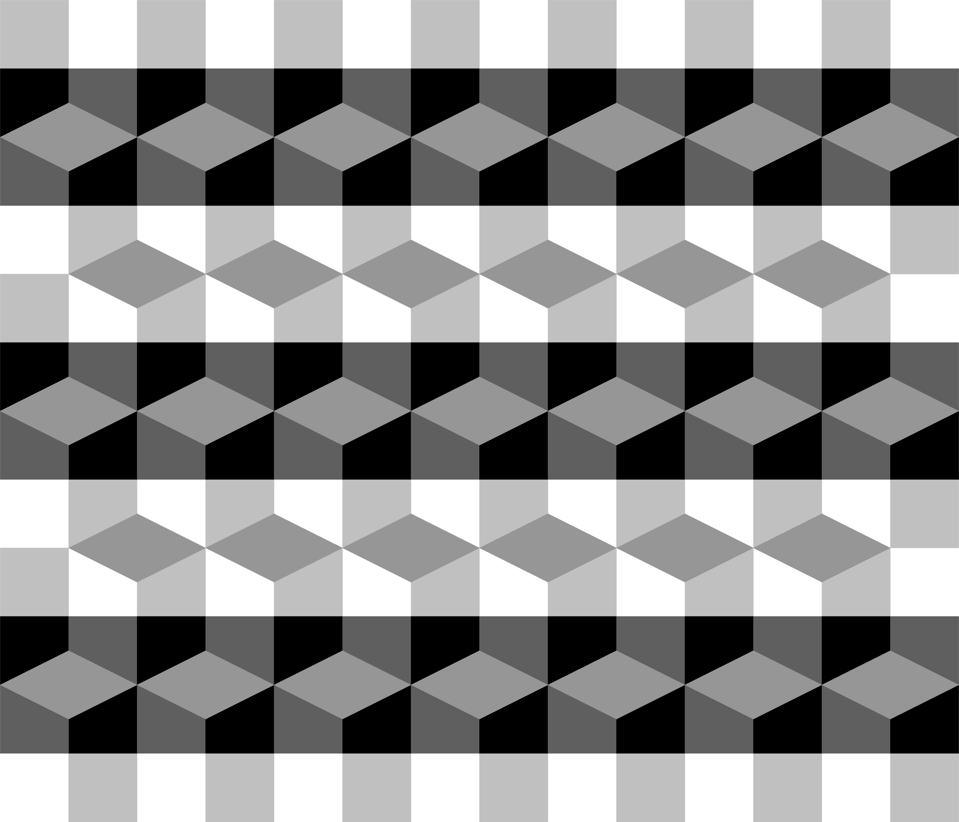  Adelson’s wall-of-blocks illusion  There appear horizontal arrays of bright or dark diamonds, though they are the same luminance.  <Adelson, 1993> | 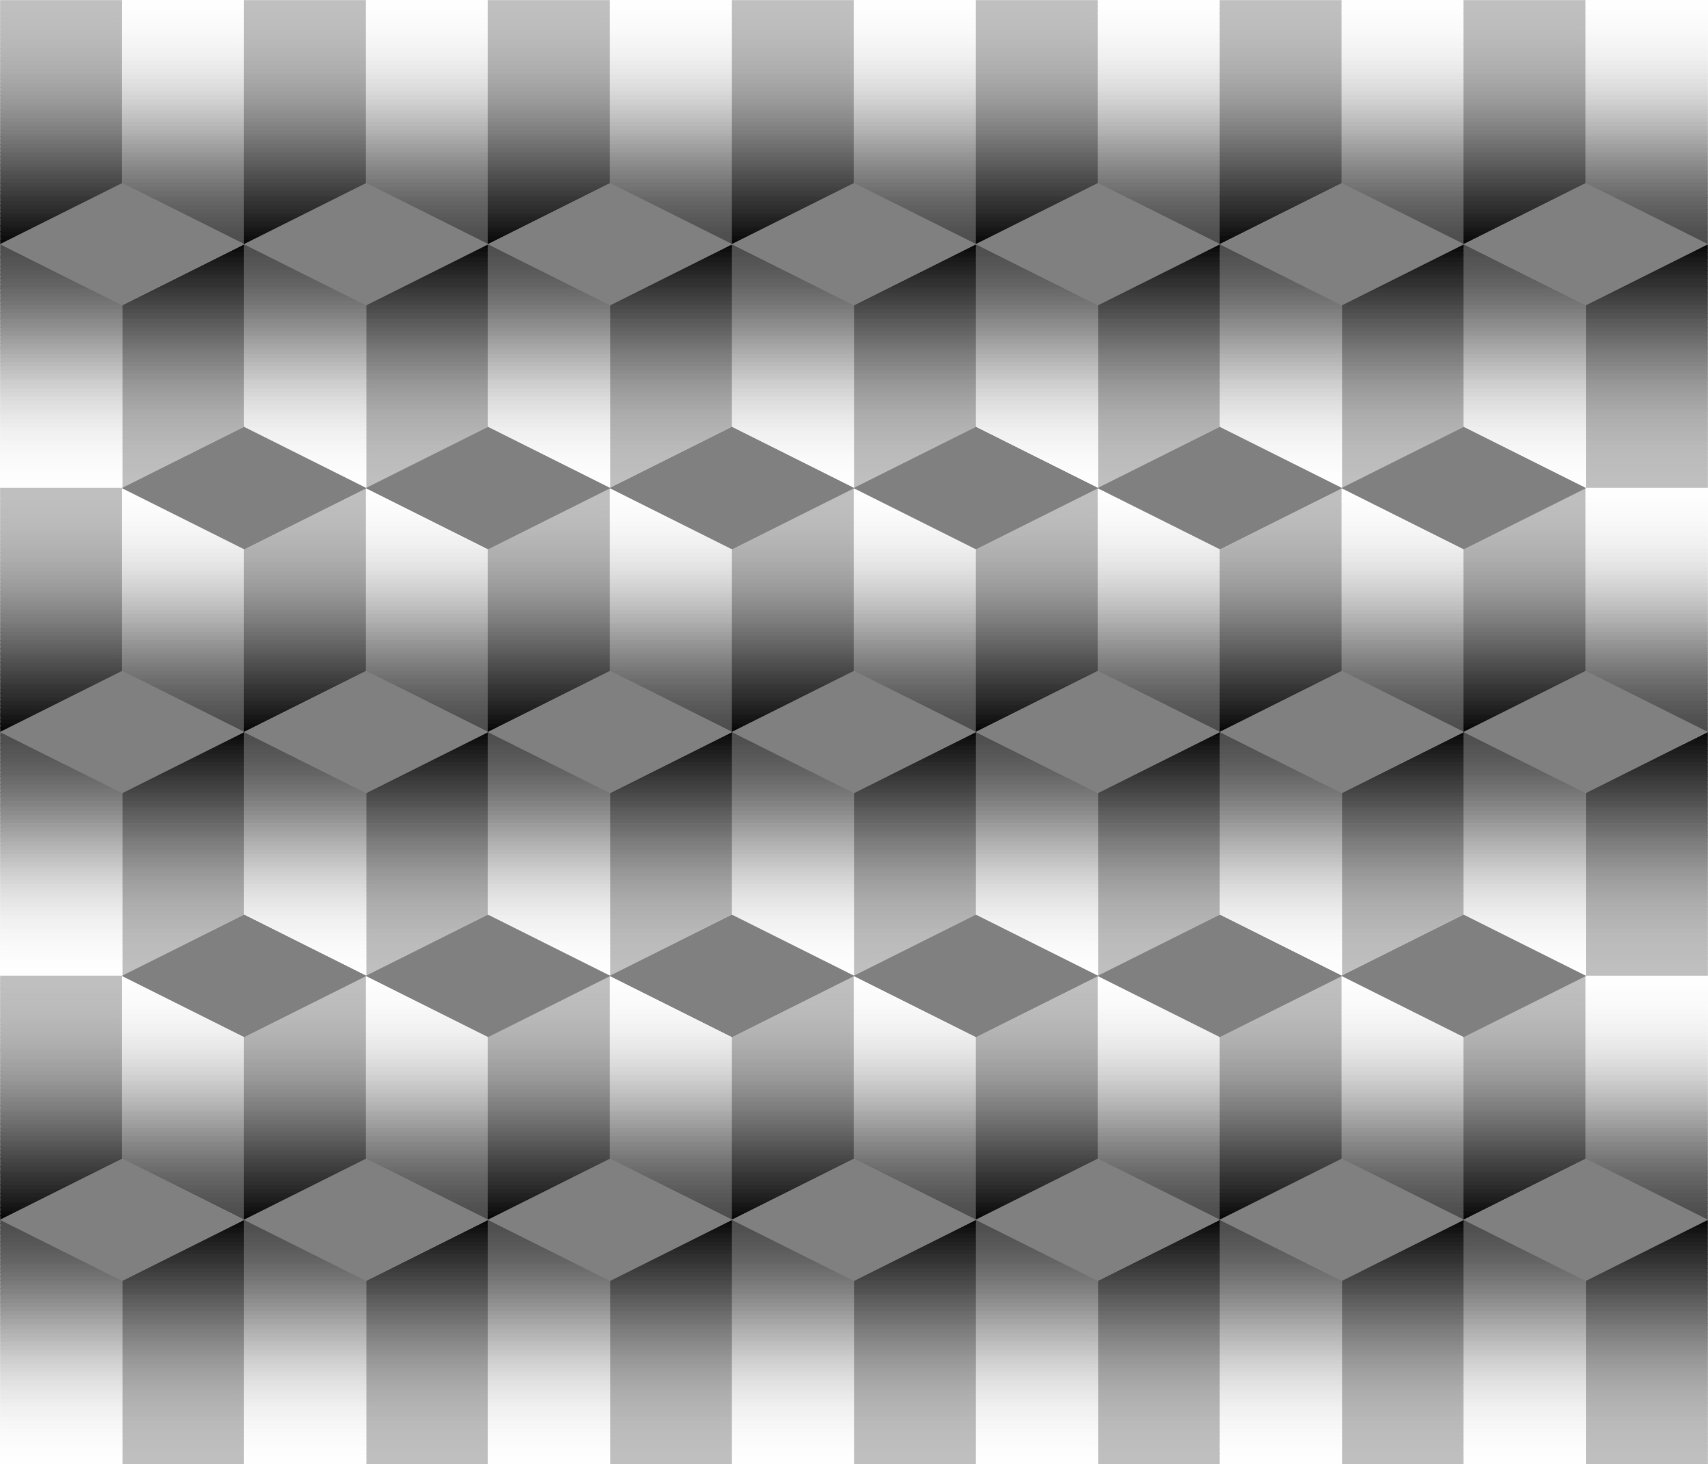  Logvinenko’s wall-of-blocks illusion  There appear horizontal arrays of bright or dark diamonds, though they are the same luminance.  <Logvinenko, 1999>
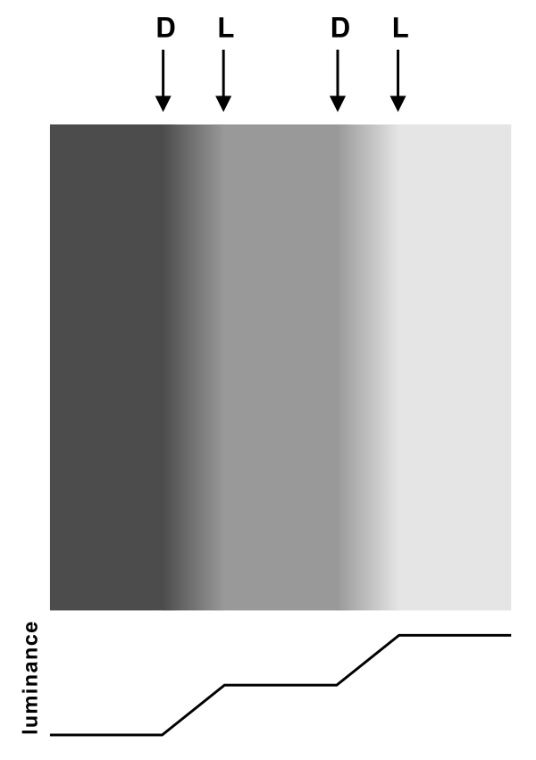  Mach band Illusory light (L) and dark (D) lines are observed, though this image consists of a luminance ramp flanked by continual homogeneous fields. < Mach, 1865> |   Chevreul illusion  Although each rectangle is homogeneous in luminance, the left border of each rectangle appears to be brighter than its center while the right border appears to be darker.  <Cornsweet, 1970; etc.> | 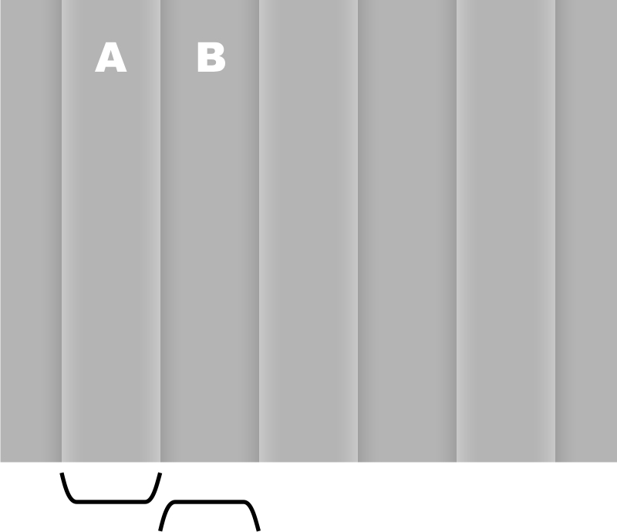  Craik-O’Brien-Cornsweet effect  There appear brighter and darker fields, though they are the same luminance (A = B) except the luminance modulation around the borders.  <Cornsweet, 1970; etc.> | 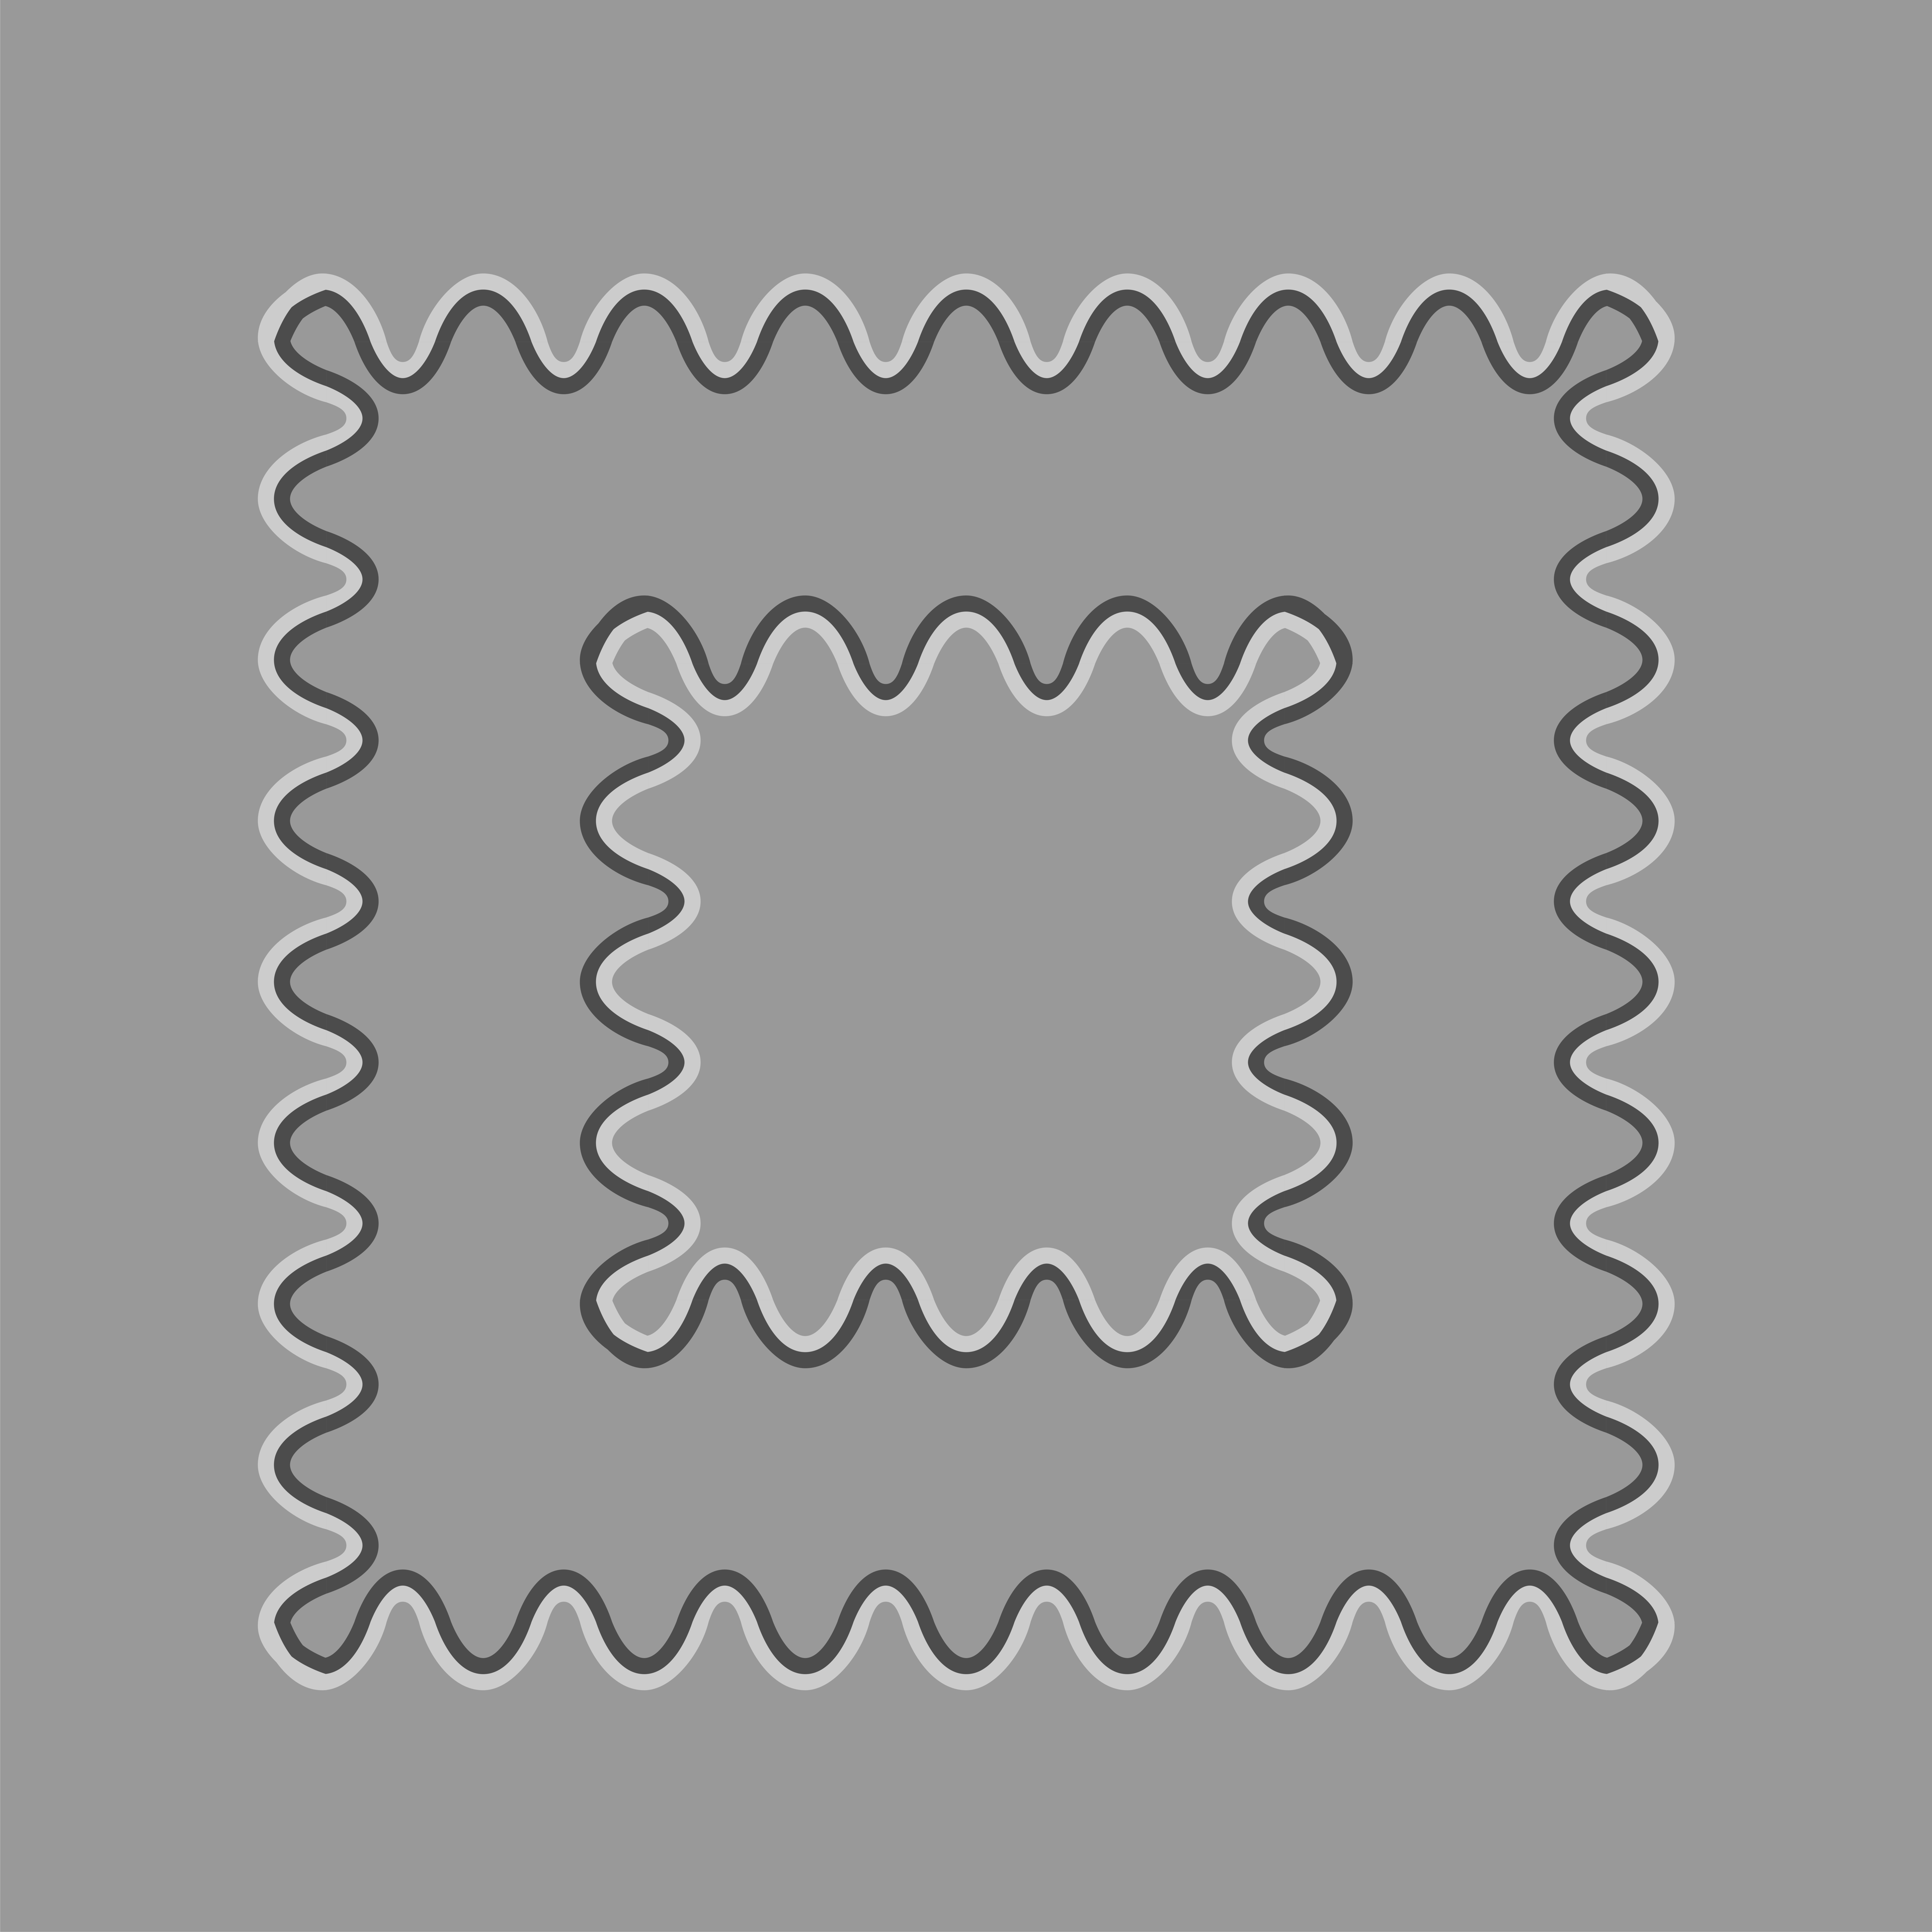  Sumi painting effect  The corridor field appears to be darker than the rest, though they are the same luminance.  <Takashima, 2008> | 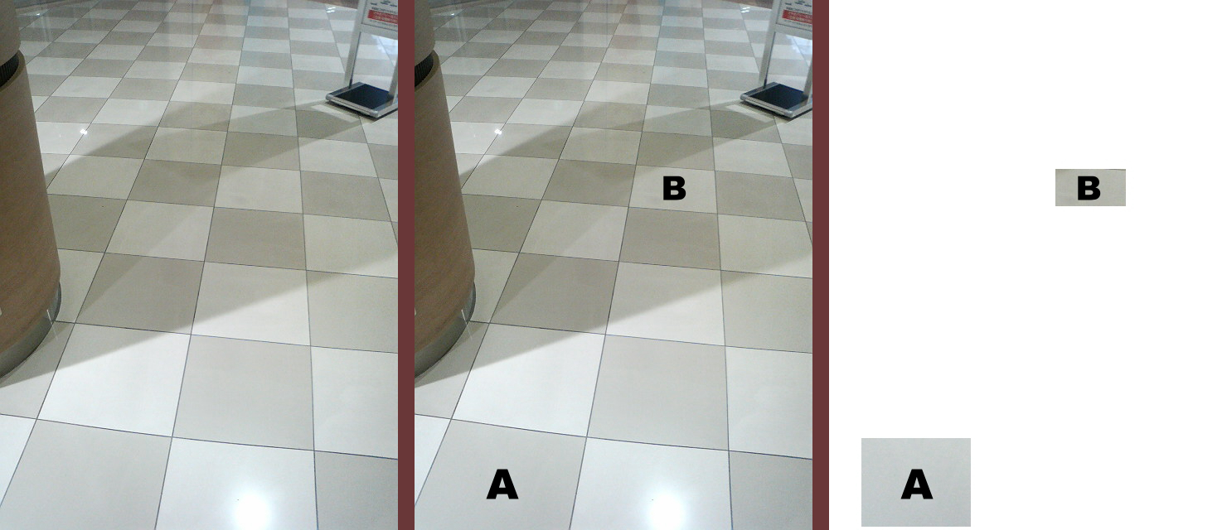  An example of lightness constancy  A appears to be darker than B though the luminance of A is higher than B  <Kitaoka, 2009>  (Original photo from hisa, Japan,)
It should be noted that these images are not necessarily precise copies of the originals.

