Handout of the 67th Annual Convention of the Japanese Psychological Association (presented on 13th September, 2003)

A quantitative study of spiral illusion

Akiyoshi Kitaoka
（Department of Psychology, College of Letters, Ritsumeikan University）

The illusion magnitude of the spiral illusion was first quantified in terms of the “equi-angle” ϕ of equiangular spirals used as comparison stimuli. As a result, spiral illusions showed no less than 10-deg tilts while linear illusions reproduced 2-deg tilts. This striking result suggests the critical differences in characteristics between polar-coordinate patterns and linear ones also in the illusion domain.

Left. Mean illusion magnitudes with SD bars of each figure of the Café Wall spirals. The magnitude was defined as (90° - ϕ). Right. Mean illusion magnitudes with SD bars of each figure of the linear (classical) Café Wall illusion. Café Wall spirals showed more illusion magnitudes than does the linear Café Wall illusion.

Test figure | Reported appearance
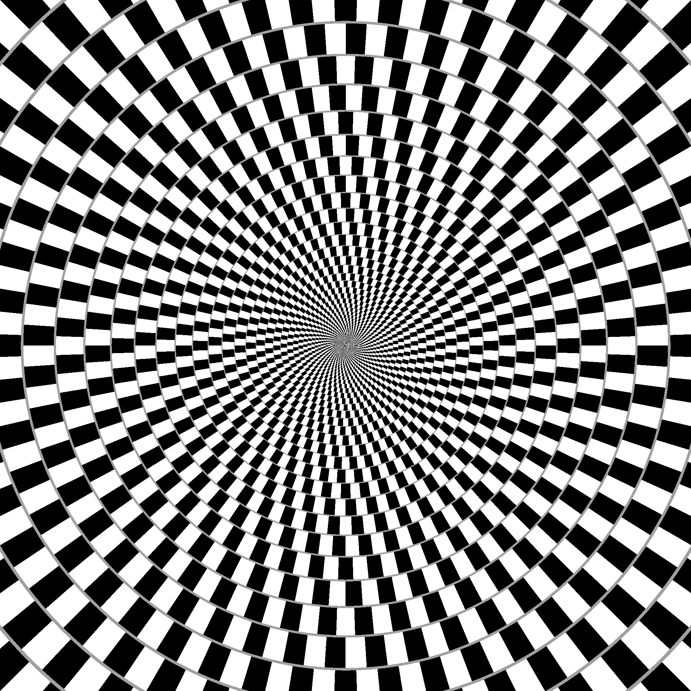  90% contraction, 48 stripes | 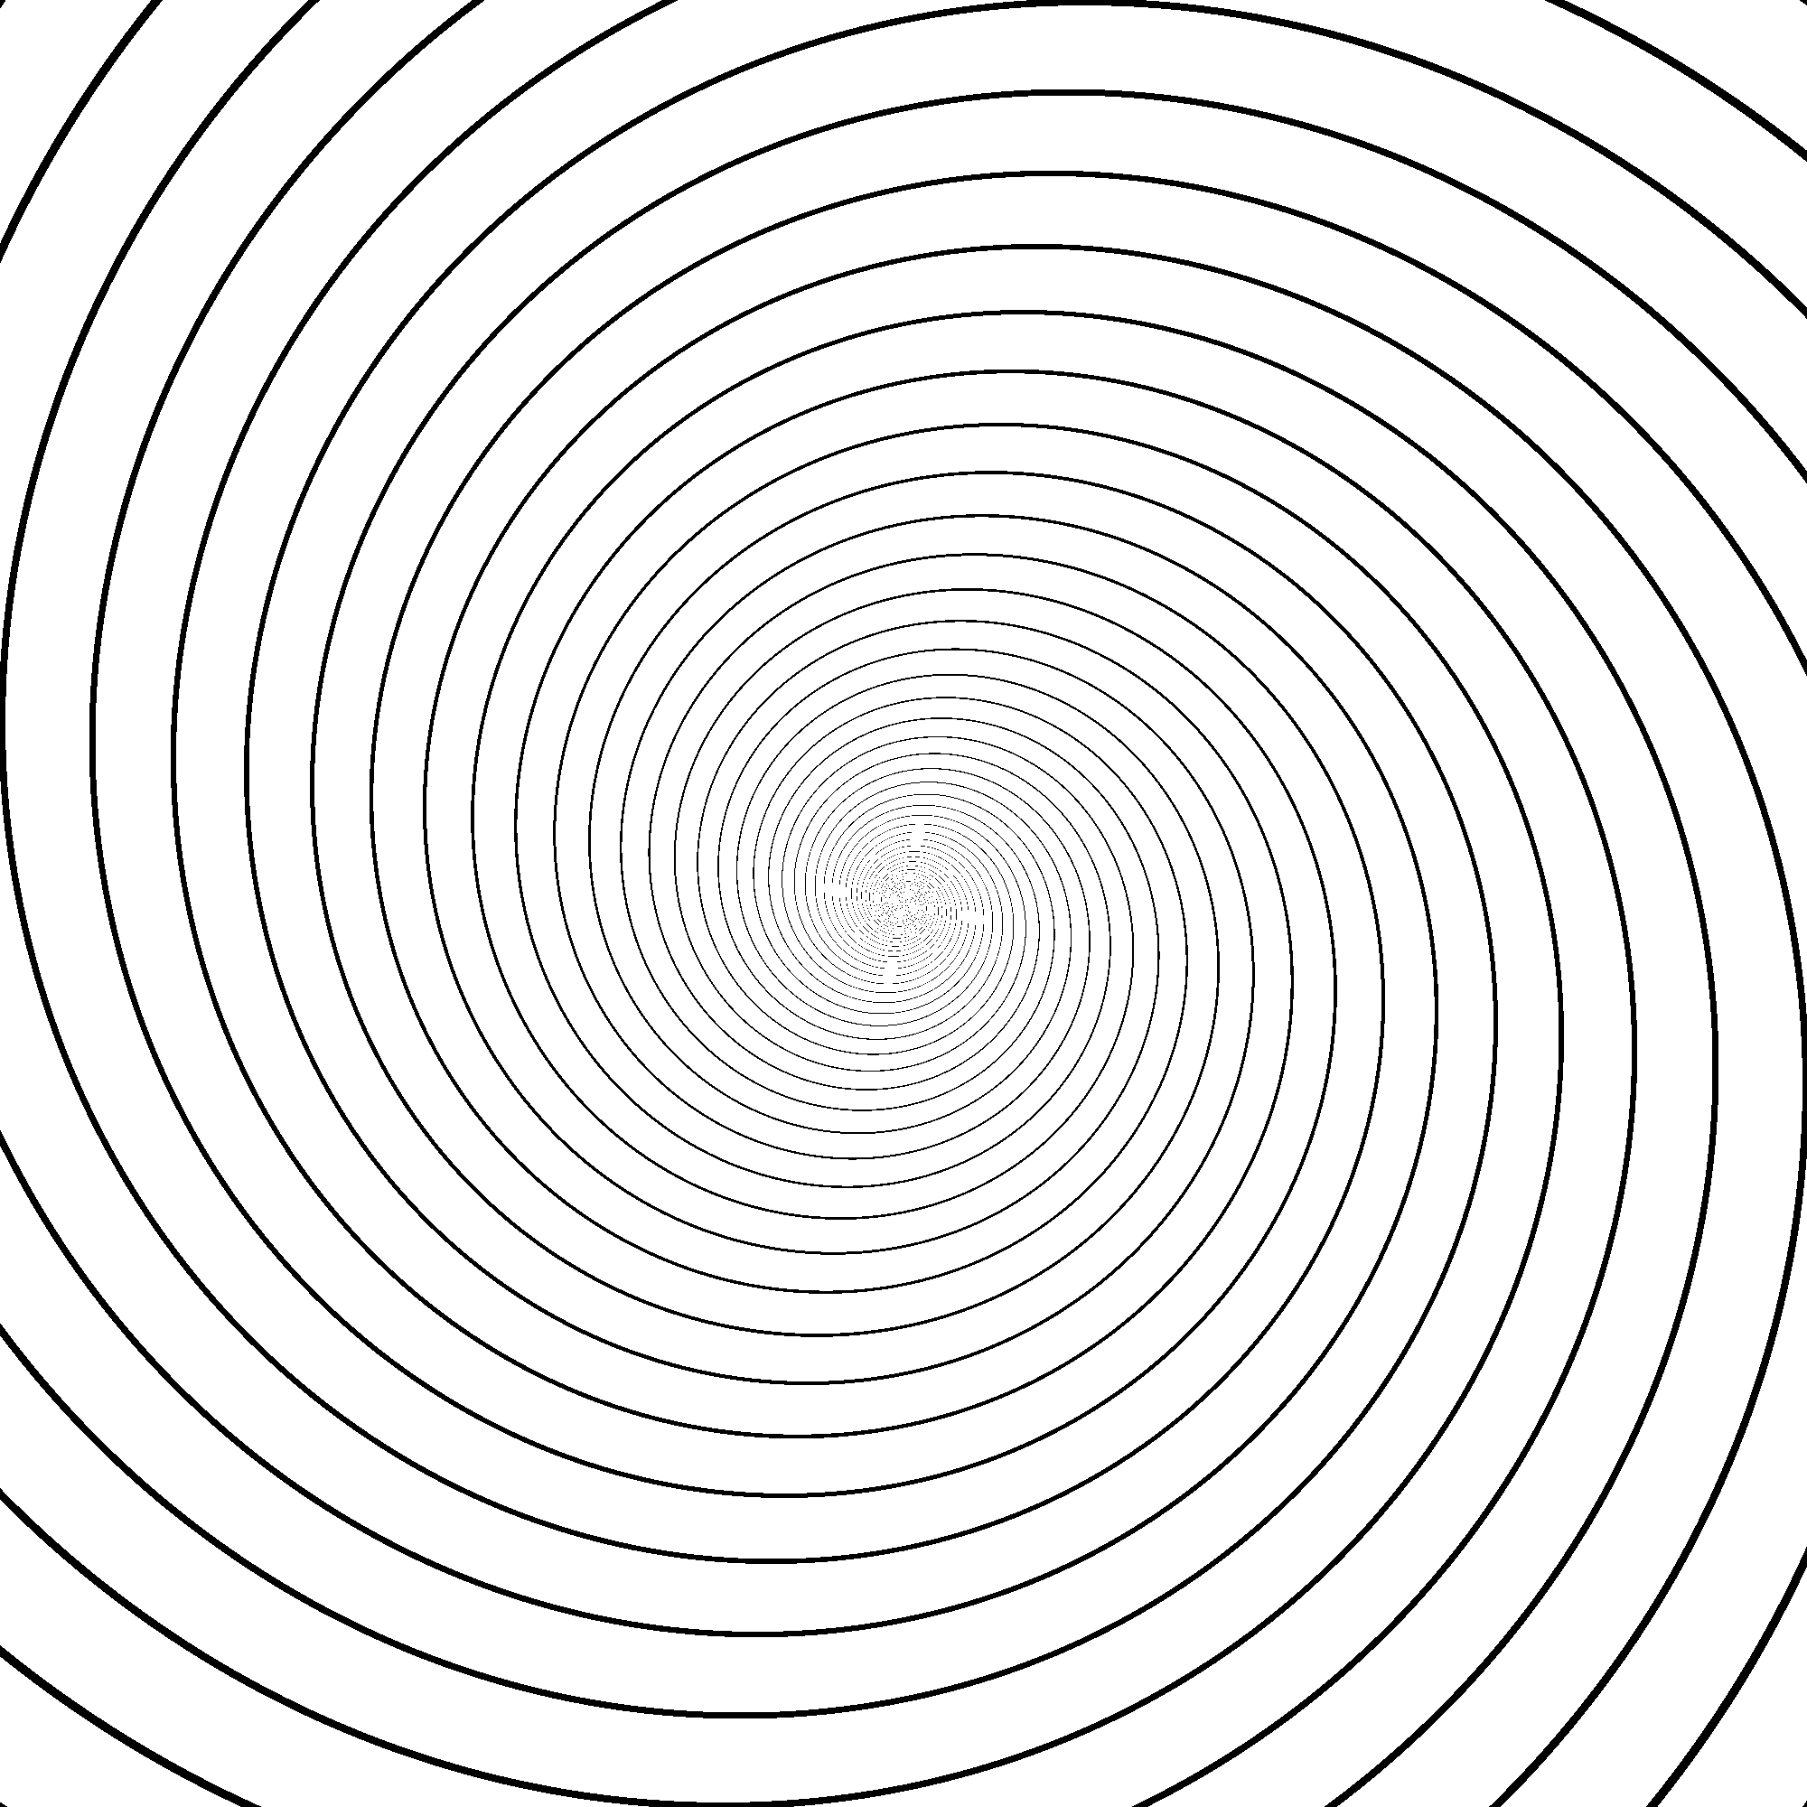  12 spirals, ϕ = 79°

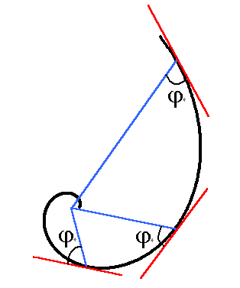
The left curve shows an equiangular spiral (r = a exp (n k θ)) (in this case n = 1), where the line that connects any point on the curve to the center of the spiral forms a constant angle (ϕ = arctan(1/(n k))) with the tangent of the point. In this figure, ϕ = 65°.
http://www.ritsumei.ac.jp/~akitaoka/index-e.html

