視覚科学フォーラム第22回研究会・2018年9月5日17:30-17:45・立命館大学大阪いばらきキャンパス

“A color-dependent motion illusion based upon speed differences”
Akiyoshi Kitaoka (Ritsumeikan University)
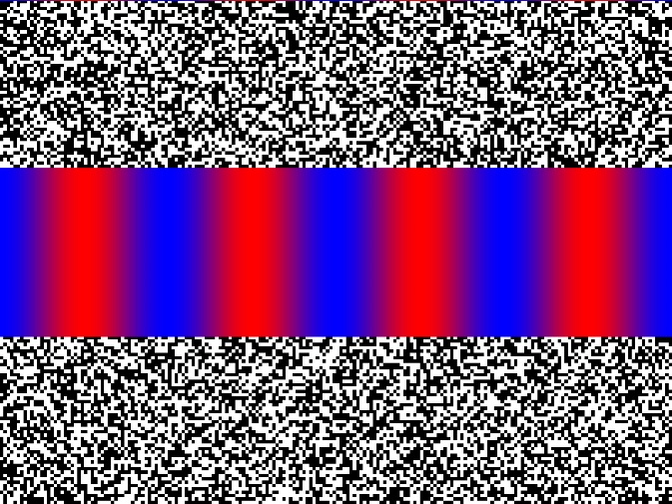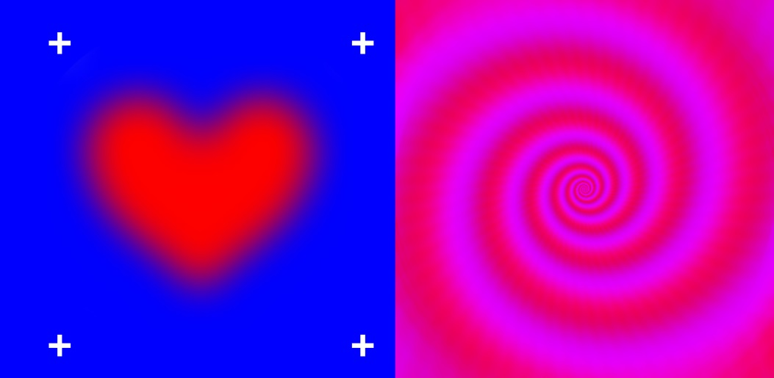
The red-blue grating appears to move laterally. Blurry-heart illusion and the color-dependent Fraser-Wilcox illusion

Hearts appear to swing when the image is swayed.
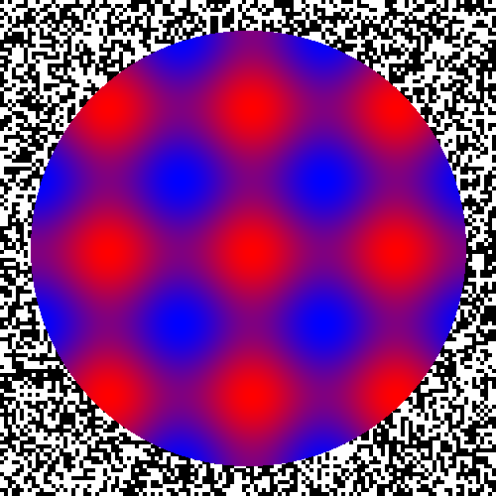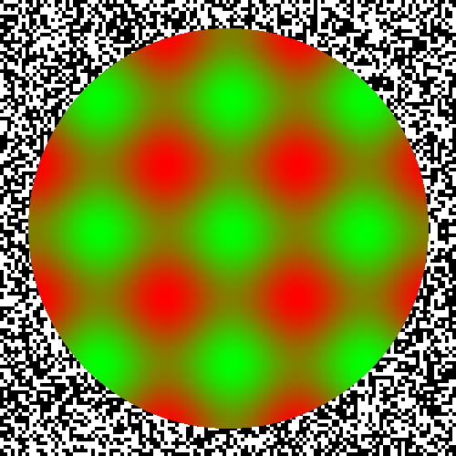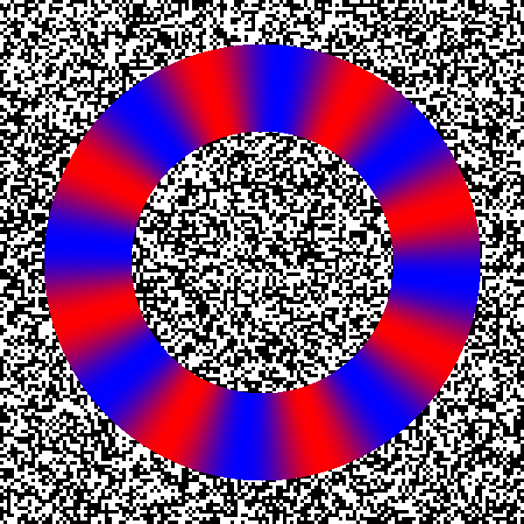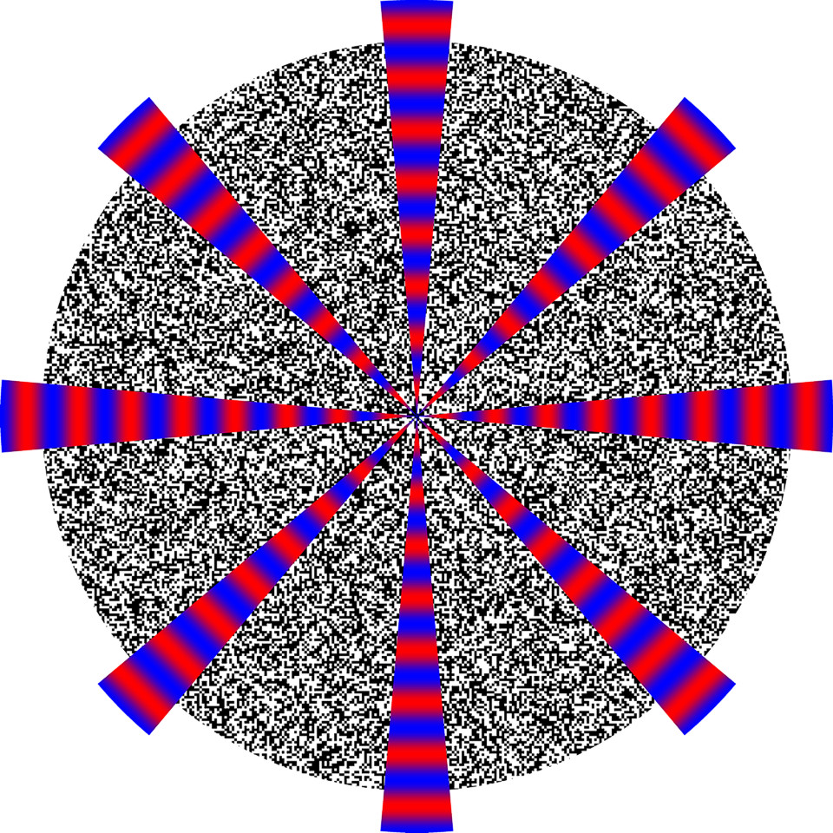

http://www.psy.ritsumei.ac.jp/~akitaoka/VisionScienceForum2018.html

