Visual Localization in Space-Time University of Sussex August 22-24, 2002, Poster
A classification of anomalous motion illusions
Akiyoshi Kitaoka
Department of Psychology, Ritsumeikan University, Kyoto, Japan

Anomalous motion illusions including the Ouchi illusion generates a positional shift of a particular part of a stationary stimulus. Here I try to classify them. Type I: The Ouchi illusion and several new illusions, showing illusory motion in the direction perpendicular to that of the global motion. Type II: An illusion that gives illusory motion in the same direction as that of the global motion and is produced by the difference in visual latency that depends on lightness contrast (Kitaoka and Ashida, ECVP2002, August 29). Type III: An illusion that gives illusory motion in the same direction as that of the global motion and is triggered by the difference in apparent speed. Type IV: An illusion that shows illusory motion in chromatic edges, probably dependent on dynamic changes in chromatic aberration. In the Type IV, positional shifts generate illusory motion whereas in the Types I - III illusory motion induces positional shifts.
Visual Localization in Space-Time Poster August 23, 2002 University of Sussex
“A classification of anomalous motion illusions”
Akiyoshi Kitaoka (Department of Psychology, Ritsumeikan University, Kyoto, Japan) akitaoka@Lt.ritsumei.ac.jp
Type | Characteristics | Direction of illusory motion | Source of illusion | Examples | Notes
I | Smooth retinal slip generates this type | Perpendicular to the global motion | Misintegration of motion signals? |  | The Ouchi illusion is included.  http://www.ritsumei.ac.jp/  ~akitaoka/index-e.html
II | Low-contrasted regions appear to move | The same direction as the global motion | The difference in processing time |  | Kitaoka and Ashida,  ECVP2002 Glasgow  “An anomalous motion illusion based upon signal delay”
III | Low-spatial-frequency parts appear to move | The same direction as the global motion | The difference in apparent speed? | 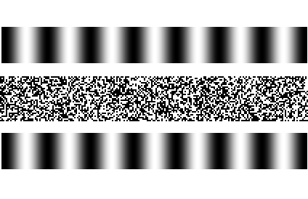 | Kitaoka and Ashida, forthcoming
IV | Chromatic edges appear to move | The same direction as the shift of chromatic aberration? | Dynamic chromatic aberration? |  | Kitaoka, forthcoming  cf. Liebman effect
Subtypes
I´ | Smooth retinal slip generates this type | The same direction as the stimulus array | Misintegration of motion signals? | 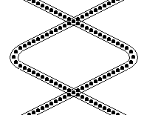 | http://www.ritsumei.ac.jp/  ~akitaoka/index-e.html
II´ | Fixating on the figure generates this type  (microsaccade-dependent?) | The same direction as the global motion | The difference in processing time? |  | http://www.ritsumei.ac.jp/  ~akitaoka/index-e.html
There are other types or subtypes that are not shown here.

