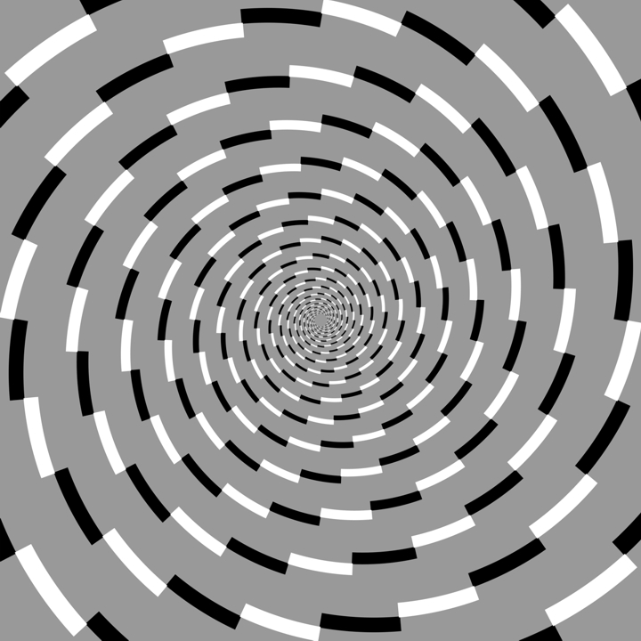

Tilt illusions and anomalous motion illusions
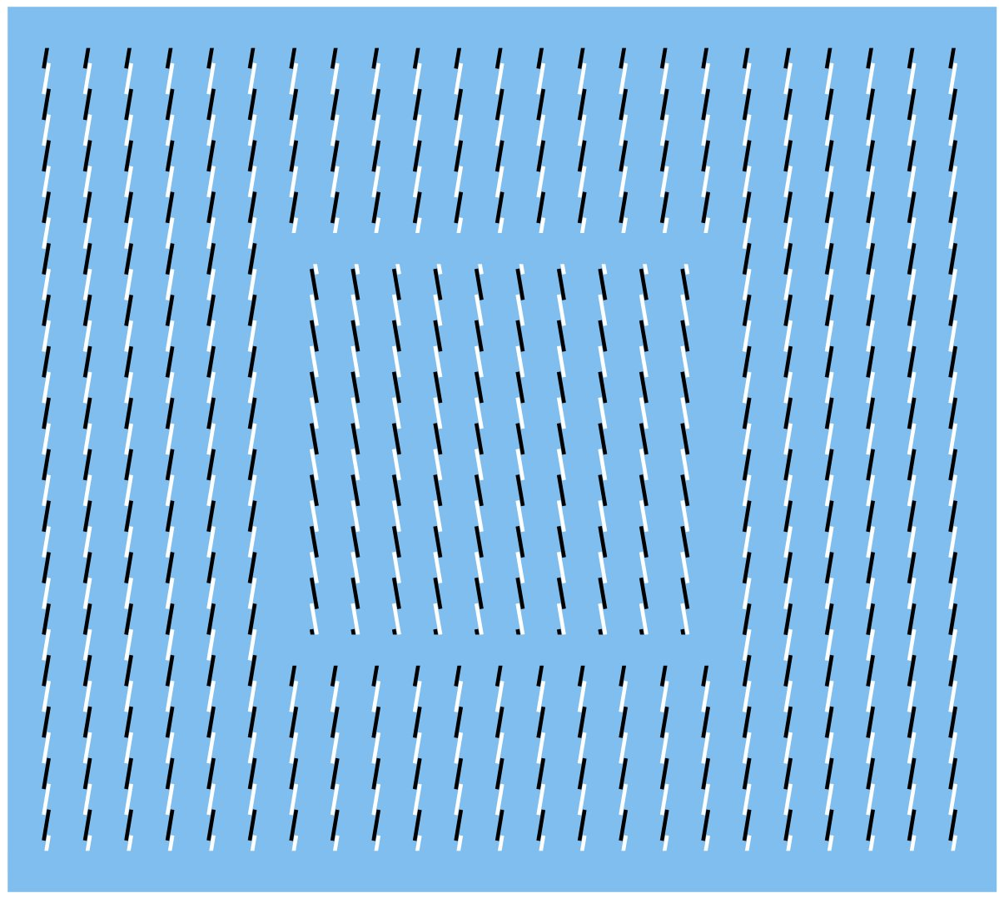
Prof. Akiyoshi Kitaoka
Department of Psychology,
Ritsumeikan University

Jul. 2, 2010 15:00-16:30
3F Seminar Room, BSI Central Bldg.

Abstract
The Fraser illusion is a well-known tilt illusion. Recently I have identified the “Fraser illusion family”, which consists of six tilt illusions including the Café Wall illusion. Moreover, I have reduced each illusion into an array of four elemental patterns. Here I point out the similarity of these tilt illusions to the four-stroke motion including phi and reversed phi movement. This idea leads to a clear understanding of a particular group of anomalous motion illusions.
Host: Shiro Usui (ext. 7601)

