Does the peripheral drift illusion generate illusory motion in depth?

Akiyoshi Kitaoka
Department of Psychology, Ritsumeikan University, Kyoto 603-8577, Japan
E-mail: akitaoka@lt.ritsumei.ac.jp

Hiroshi Ashida
Graduate School of Letters, Kyoto University, Kyoto 606-8501, Japan
E-mail: ashida@bun.kyoto-u.ac.jp

Ikuya Murakami
Human and Information Science Laboratory
NTT Communication Science Laboratories
Atsugi, Kanagawa 243-0198, Japan
Email: ikuya@apollo3.brl.ntt.co.jp

Abstract
This study examined whether the peripheral drift illusion can yield apparent motion in depth or not. The result was negative.

The peripheral drift illusion refers to an anomalous motion illusion that occurs in a stationary image when seen in the peripheral vision [1, 2, 3]. Recently, we proposed a pictorial condition that strongly generates the peripheral drift illusion, which indicates the following order: black, dark-gray, white, and light-gray [4].
Here we point out the resemblance between this rule and the stimulus configuration of Gregory and Heard [5] who examined the motion perception, positional shifts, and the stereoscopic depth perception of solid rectangles flanked by line segments. When a dark-gray (light-gray) rectangle is flanked by a black line segment on one side and a white line segment on the other side and is placed in front of a light-gray (dark-gray) background, the rectangle appears to shift toward the black (white) line segment (Figure 1). However, they found that the rectangle appears to move in the opposite direction when the luminance of the background is increasing or decreasing. Moreover, they examined the motion in depth when mirror images of the rectangle are projected to both eyes and the luminance of the background is dynamically modulated. In this case, however, the direction of perceived motion in depth is opposite to the direction expected from the apparent motion.
Figure 1. The rectangles of Gregory and Heard. When a dark-gray rectangle is flanked by a black line segment on one side and a white line segment on the other side and is placed on a light-gray background, the rectangle appears to shift toward the black line segment (indicated by a black arrow). When the luminance of the background is increasing, the rectangle appears to shift toward the white line segment (indicated by a white arrow)

Although the peripheral drift illusion does not require any dynamic change of luminance, the direction of motion is the same as that of Gregory and Heard. Thus, we tried to observe illusory motion in depth in a stereogram that monocularly gives the peripheral drift illusion.

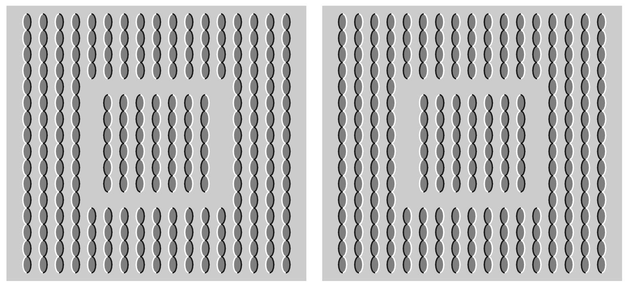
Figure 2. A stereogram that consists of mirror images of the peripheral drift illusion. In the left image, the inset appears to move rightward while the inset in the right image appears to move leftward. When observers cross-fuse them, the inset appears to be stationary in front of the background.

As a result, there was no illusory motion in depth; instead, we perceived the depth order opposite to the expected one (Figure 2). This finding is consistent with Gregory and Heard. Moreover, we examined another stereogram in which, in one image, the luminances between the objects and the background were exchanged in one image while those of the flanks were constant (Figure 3). In this case, either, there was no illusory motion in depth, or a slight difference in depth that accords with the expected one from the positional shifts given by the peripheral drift illusion.

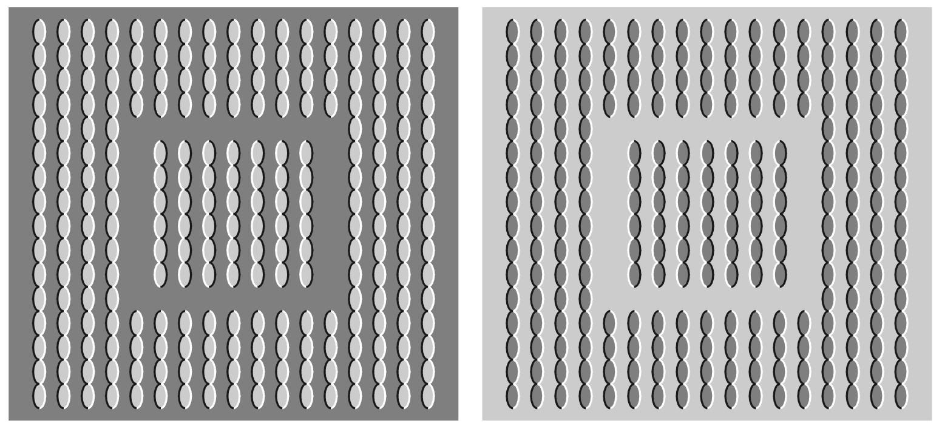
Figure 3. Another stereogram. In the left image, the inset appears to move rightward while the inset in the right image appears to move leftward. When observers cross-fuse them, the inset appears to be flush with or be slightly behind the background.

In conclusion, the peripheral drift illusion does not seem to generate illusory motion in depth.

References

[1] Fraser A, Wilcox K J, 1979 “Perception of illusory movement” Nature 281 565-566
[2] Faubert J, Herbert A M, 1999 “The peripheral drift illusion: A motion illusion in the visual periphery” Perception 28 617-621
[3] Naor-Raz G, Sekuler R, 2000 “Perceptual dimorphism in visual motion from stationary patterns” Perception 29 325-335
[4] Kitaoka A, Ashida H, 2003 “Phenomenal characteristics of the peripheral drift illusion” Vision (Japan) 15 261-262
[5] Gregory R L, Heard P, 1983 “Visual dissociations of movement, position, and stereo depth: Some phenomenal phenomena” Quarterly Journal of Experimental Psychology 35A 217-237

