GESTALT THEORY IN JAPAN: ITS LEGACY AND CURRENT STATUS Noguchi, K., Kitaoka, A., and Takashima, M. (2008) Gestalt-oriented perceptual research in Japan: Past and present. Gestalt Theory, 30, 11-28. より抜粋
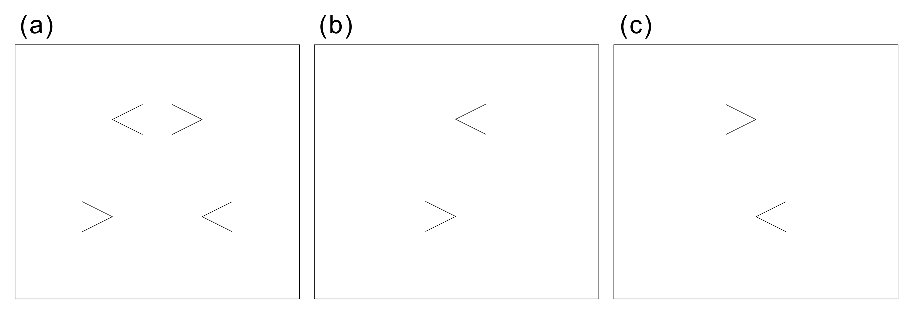
Figure 3. Morinaga’s paradox, Type I (size illusion vs. position illusion). (a) The Müller-Lyer illusion remains even if the horizontal line is not real but subjective. On the other hand, the perceived alignment of the tips is reversed (Morinaga misalignment illusion) when the observer pays attention to either the left half (b) or the right half (c).
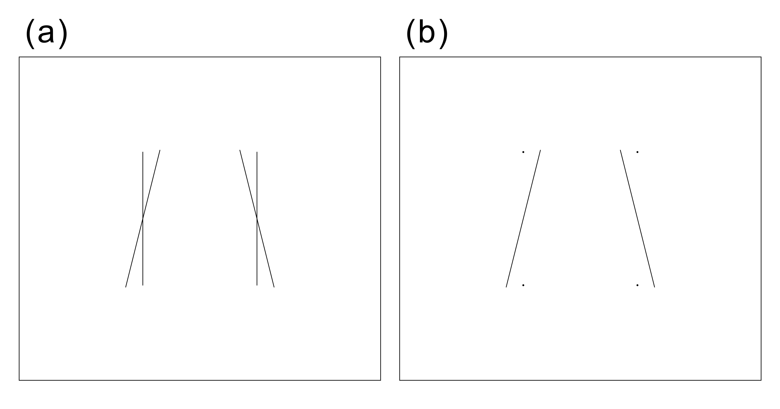
Figure 4. Morinaga’s paradox, Type II (orientation illusion vs. size illusion). (a) The Zöllner illusion. The two vertical lines appear to tilt as if they are tapered downward. (b) On the other hand, the perceived distance between the line ends of each horizontal pair is reversed when dots are drawn at the ends of the vertical lines. The upper distance appears to be shorter than the lower (size illusion). In the second author’s (Kitaoka’s) observation, position illusion accords with the size illusion and is rather clear when the observer pays attention to either the left half or right half, in which the left alignment appears to tilt clockwise while the right counterclockwise.
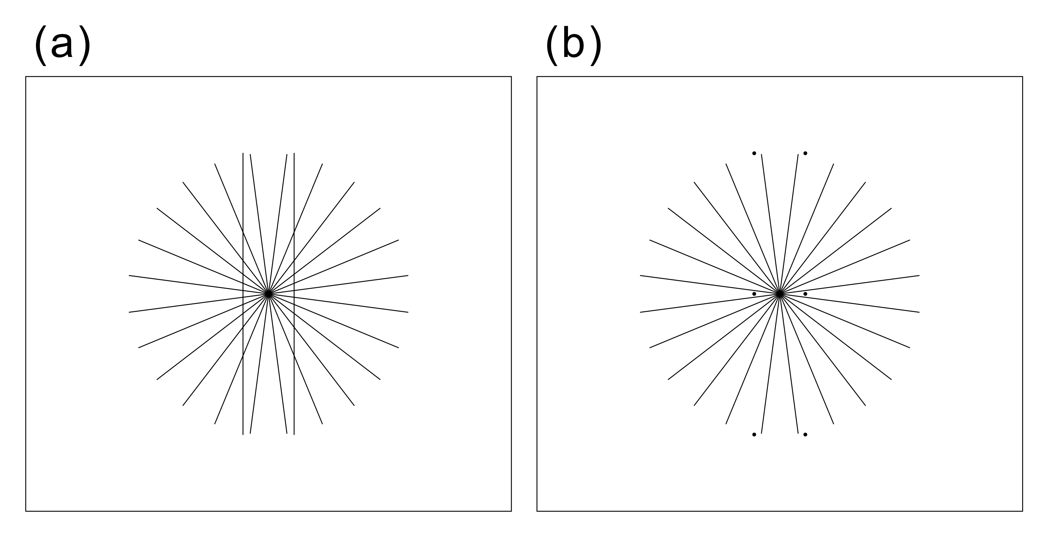
Figure 5. Morinaga’s paradox, Type II. (a) The Hering illusion. The two vertical lines appear to bulge outward. (b) On the other hand, The virtual line connecting the line ends and the middle point of each vertical line appears to curve inward.
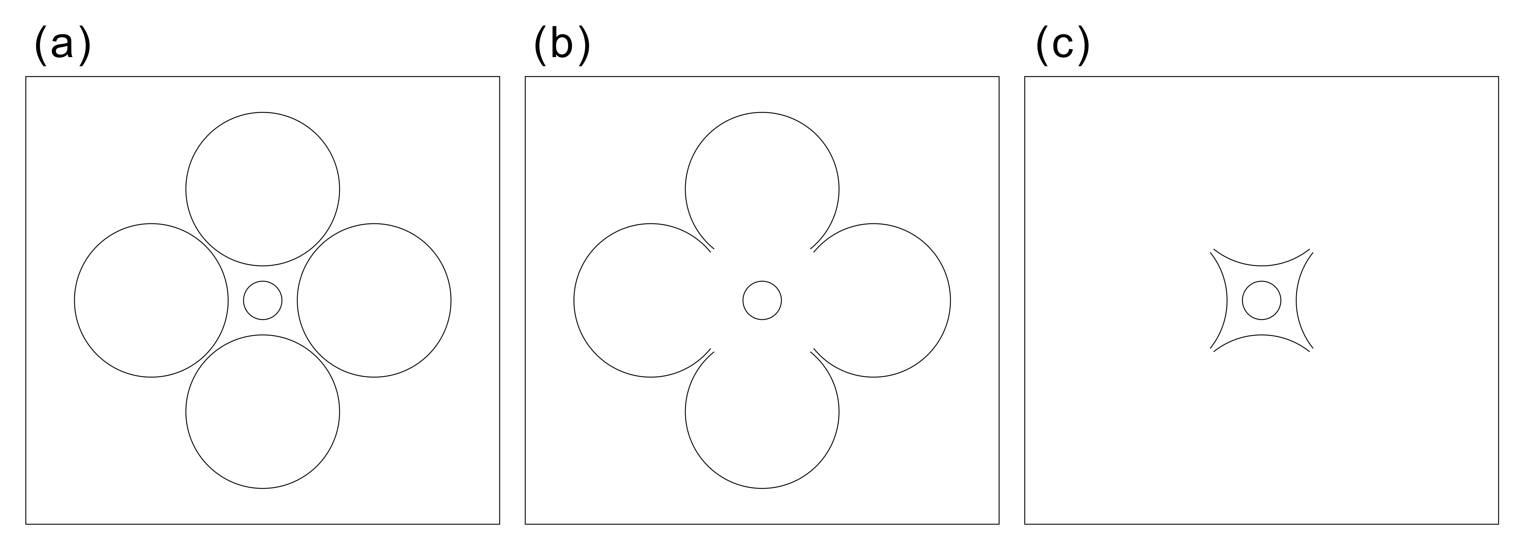
Figure 6. Morinaga’s paradox, Type III (size contrast vs. size assimilation). (a) The underestimation effect of the Ebbinghaus illusion or Titchener circles. The circle surrounded by larger circles appears to be smaller than it is. This effect is not given from the proximal parts of the larger circles as suggested by the vector-field theory. (b) When their proximal parts are removed, the underestimation effect of the Ebbinghaus illusion remains. (c) If their distal parts are removed, the inner circle appears to be larger than it is.

