"Is age related to the color-dependent Fraser-Wilcox illusion?" presented by Akiyoshi Kitaoka @ECVP2014 Illusion Night, Belgrade, Serbia (August 25, 2014)

Your comments if any

A survey

Please check how you see illusion or that you do not see illusion.

□ Disks appear to rotate clockwise strongly.

□ Disks appear to rotate clockwise.

□ Disks appear to rotate clockwise slightly.

□ Disks appear to be stationary.

□ Disks appear to rotate counterclockwise slightly.

□ Disks appear to rotate counterclockwise.

□ Disks appear to rotate counterclockwise strongly.

Your age, please. years old.

Thank you!

Akiyoshi

"Is age related to the color-dependent Fraser-Wilcox illusion?" presented by Akiyoshi Kitaoka @ECVP2014 Illusion Night, Belgrade, Serbia (August 25, 2014)

Your comments if any

A survey

Please check how you see illusion or that you do not see illusion.

□ Disks appear to rotate clockwise strongly.

□ Disks appear to rotate clockwise.

□ Disks appear to rotate clockwise slightly.

□ Disks appear to be stationary.

□ Disks appear to rotate counterclockwise slightly.

□ Disks appear to rotate counterclockwise.

□ Disks appear to rotate counterclockwise strongly.

Your age, please. years old.

Thank you!

Akiyoshi

"Is age related to the color-dependent Fraser-Wilcox illusion?" presented by Akiyoshi Kitaoka @ECVP2014 Illusion Night, Belgrade, Serbia (August 25, 2014)

The aim to explore the relationship between the illusion and age is to compare with the weak but significant negative correlation between the illusion magnitude of “Rotating snakes” and age.

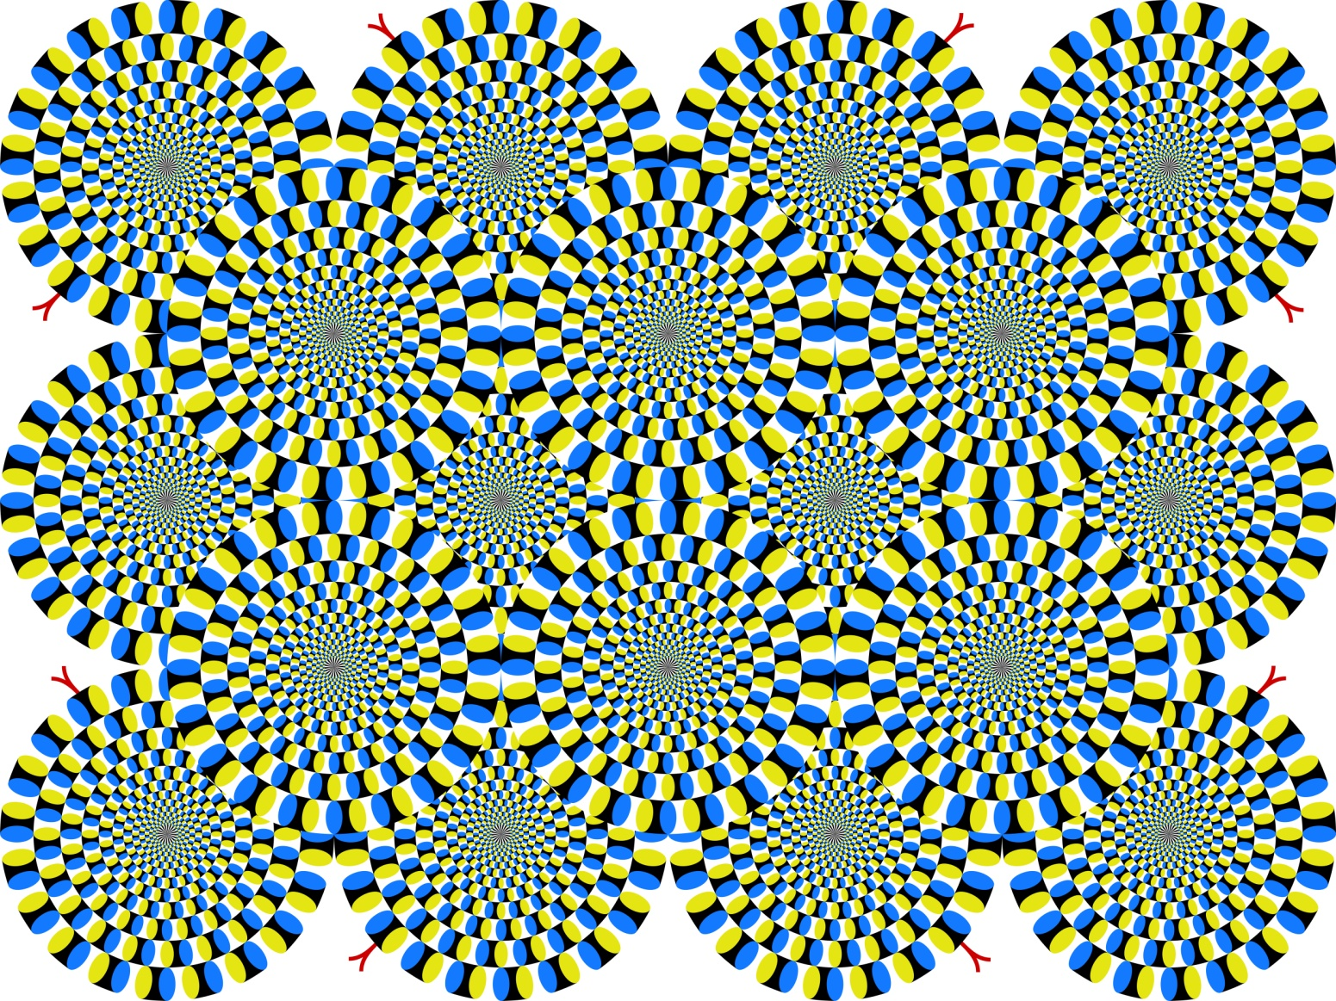

Table 1. The effect of age on the “Rotating snakes” illusion

-------------------------------------------------------------------

Age n Score 0 1 2 3

-------------------------------------------------------------------

0-9 169 0% 6% 17% 78%

10-19 710 1% 6% 19% 74%

20-29 219 1% 6% 27% 65%

30-39 219 1% 7% 21% 70%

40-49 221 2% 9% 29% 60%

50-59 138 8% 19% 30% 43%

60-69 98 5% 28% 38% 30%

70-79 61 15% 25% 33% 28%

80-92 28 21% 7% 39% 32%

-------------------------------------------------------------------

Total 1863 3% 9% 24% 64%

-------------------------------------------------------------------

Rating scores 0, 1, 2, 3 mean that observers reported no illusion, a slight illusion, an illusion, a strong illusion, respectively. Percentages indicate proportions in each age.

Kitaoka, A. (forthcoming). The Fraser-Wilcox illusion and its extension. A. Shapiro and D. Todorović (Eds.), Oxford Compendium of Visual Illusions, Oxford University Press.